SQL (STRUCTURED QUERY LANGUAGE) AND DATA BASE MANAGEMENT SYSTEM (DBMS)
1. SQL Basics
- What is SQL, and how is it used in data science?
SQL, or Structured Query Language, is a standard programming language used for managing and querying relational databases. In data science, SQL is fundamental for data retrieval, manipulation, and preprocessing, which are essential for analysis and +building models. Data scientists use SQL to query large datasets, perform aggregations, filter data, and even join tables to create a unified dataset for analysis.
- What is Database?
A Database is defined as a structured form of data storage in a computer or a collection of data in an organized manner and can be accessed in various ways. It is also the collection of schemas, tables, queries, views, etc. Databases help us with easily storing, accessing, and manipulating data held on a computer. The Database Management System allows a user to interact with the database.
- DIFFERENCE BETWEEN CHAR and VARCHAR?
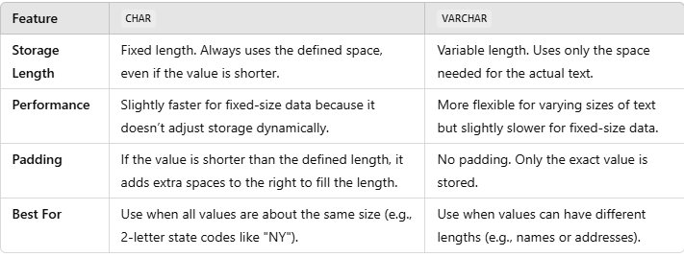
- Explain the difference between SQL and NoSQL databases.
SQL databases are relational and use structured schema-based tables to store data, making them suitable for applications that need complex queries and transactions. Examples include MySQL and PostgreSQL. NoSQL databases, on the other hand, are non-relational and handle semi-structured or unstructured data, using formats like JSON or BSON. They’re suitable for applications needing flexible schemas and scalability, such as MongoDB and Cassandra. SQL is preferred for ACID-compliant transactions, while NoSQL is more suited for high-availability and horizontal scaling.

Does SQL support programming language features?
It is true that SQL is a language, but it does not support programming as it is not a programming language, it is a command language. We do not have conditional statements in SQL like for loops or if..else, we only have commands which we can use
.to query, update, delete, etc. data in the database. SQL allows us to manipulate data in a database.
- What is the view in SQL?
Views in SQL are a kind of virtual table. A view also has rows and columns as they are on a real table in the database. We can create a view by selecting fields from one or more tables present in the database. A View can either have all the rows of a table or specific rows based on certain conditions.

- What is the difference between DDL, DML, DCL, and TCL commands? Give examples.
• DDL (Data Definition Language): Commands used to define or modify database structures. Examples: CREATE, ALTER, DROP, Truncate.
• DML (Data Manipulation Language): Commands that manage data within tables. Examples: SELECT, INSERT, UPDATE, DELETE.
• DCL (Data Control Language): Commands to control access to data. Examples: GRANT, REVOKE.
• TCL (Transaction Control Language): Commands that handle transactions within a database. Examples: COMMIT, ROLLBACK, SAVEPOINT, Transaction, Release Savepoint.
- Explain the basic SQL operations: SELECT, INSERT, UPDATE, and DELETE.
• SELECT: Used to retrieve data from one or more tables. Example: SELECT * FROM employees;
• INSERT: Adds new rows of data into a table. Example: INSERT INTO employees (name, age) VALUES ('John Doe', 30);
• UPDATE: Modifies existing records in a table. Example: UPDATE employees SET age = 31 WHERE name = 'John Doe';
• DELETE: Removes rows from a table. Example: DELETE FROM employees WHERE name = 'John Doe';
- What is a primary key, and why is it important?
A primary key is a unique identifier for each row in a table. It ensures that each record is unique and cannot contain NULL values. Primary keys are crucial for maintaining data integrity and for efficient data retrieval, as they are used to reference rows in foreign keys in other tables.
- What are foreign keys and unique keys?
• Foreign Key: A column or set of columns in one table that uniquely identifies rows in another table. Foreign keys enforce referential integrity by linking tables together.
• Unique Key: A constraint that ensures all values in a column are unique, similar to a primary key, but unlike primary keys, unique keys can accept a NULL value.
- What are the differences between WHERE and HAVING clauses?
The WHERE clause filters rows before any groupings are made, while the HAVING clause filters groups after the GROUP BY operation. WHERE is used with individual records, and HAVING is applied to grouped records.
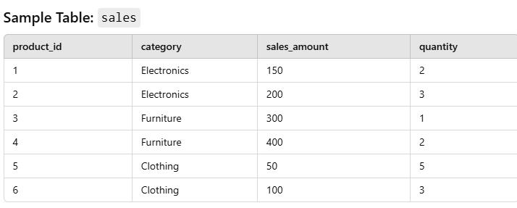
Scenario
- We want to find categories where the total sales amount is greater than 250, but we are only interested in rows where each sale had a quantity of 2 or more.
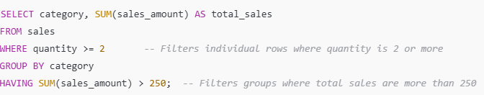

- Explain the use of GROUP BY and ORDER BY.
- • GROUP BY: Used to group rows that have the same values in specified columns, often combined with aggregate functions (e.g., SUM, COUNT). Example: SELECT department, SUM (salary) FROM employees GROUP BY department;
- • ORDER BY: Used to sort the result set in ascending (ASC) or descending (DESC) order. Example: SELECT * FROM employees ORDER BY age DESC;
- How does the DISTINCT keyword work?
- The DISTINCT keyword removes duplicate values from the result set. It applies to all columns specified in the SELECT statement. For example, SELECT DISTINCT department FROM employees; returns unique departments without duplicates.
Correct Sequence of SQL Clauses:
- FROM:
Specifies the table(s) from which data is retrieved. This is the starting point.
- JOIN (if necessary):
Used to combine rows from two or more tables. This is used after specifying the FROM clause.
- SELECT:
Defines the columns (or expressions) to retrieve from the tables.
- WHERE:
Filters rows based on specified conditions. Applied after SELECT and before grouping or aggregating data.
- GROUP BY:
Groups rows sharing a property or condition together. Used after WHERE or when aggregation functions are used.
- HAVING:
Filters groups based on aggregate conditions. Applied after GROUP BY.
- ORDER BY:
Sorts the result set based on specified columns or expressions.
- LIMIT/OFFSET (optional):
Limits the number of rows returned or skips a number of rows, often used at the end of the query.

2. Joins and Relationships
- What is a JOIN? List different types of JOINs in SQL.
A JOIN is used in SQL to combine rows from two or more tables based on a related column between them. The main types of JOINs are:
- INNER JOIN: Returns only matching rows between tables.
- LEFT JOIN (LEFT OUTER JOIN): Returns all rows from the left table and matched rows from the right table.
- RIGHT JOIN (RIGHT OUTER JOIN): Returns all rows from the right table and matched rows from the left table.
- FULL OUTER JOIN: Returns all rows from both tables, with NULL in places where there’s no match.

- Explain the difference between INNER JOIN, LEFT JOIN, RIGHT JOIN, and FULL OUTER JOIN.
• INNER JOIN: Only returns rows where there’s a match in both tables. Example: Customers with matching orders.
• LEFT JOIN: Returns all rows from the left table and matches from the right table. Rows from the left table without a match will have NULL in columns from the right table.
• RIGHT JOIN: Opposite of LEFT JOIN; returns all rows from the right table and matches from the left.
• FULL OUTER JOIN: Returns all rows from both tables. Non-matching rows in either table will show NULL for the missing columns.
- What is a self join, and when would you use it?
A self join is when a table is joined with itself. It’s useful when comparing rows within the same table, such as finding hierarchical relationships. For example, in an employee table with manager_id as a field, a self join could be used to list each employee and their manager.
- How do you perform a cross join in SQL?
A cross join returns the Cartesian product of two tables, meaning each row from the first table is combined with each row from the second table. It’s executed by using the CROSS-JOIN keyword. Example: SELECT * FROM table1 CROSS JOIN table2; This is used when all combinations of rows are needed, like matching all products with all customers in a dataset.
A Cross Join is a SQL operation that combines every row from one table with every row from another table. Essentially, it returns the Cartesian product of the two tables, meaning that every combination of rows from both tables is included in the result set.
Important Points:
- A Cross Join does not filter or join based on specific conditions or criteria.
- The result can be large, especially when both tables have a large number of rows.
- There are no ON or WHERE clauses in a Cross Join as it is purely about combining rows.

Example:
Let’s take two tables:
- Employees - with columns EmployeeID and EmployeeName.
- Departments - with columns DepartmentID and DepartmentName.
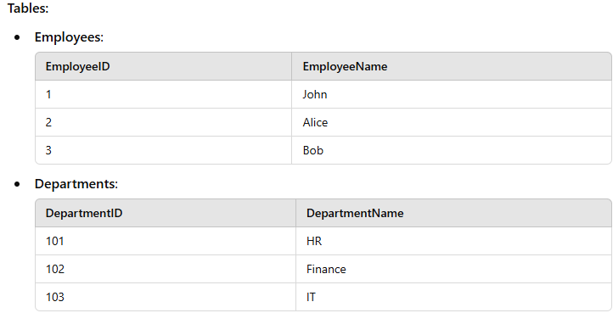
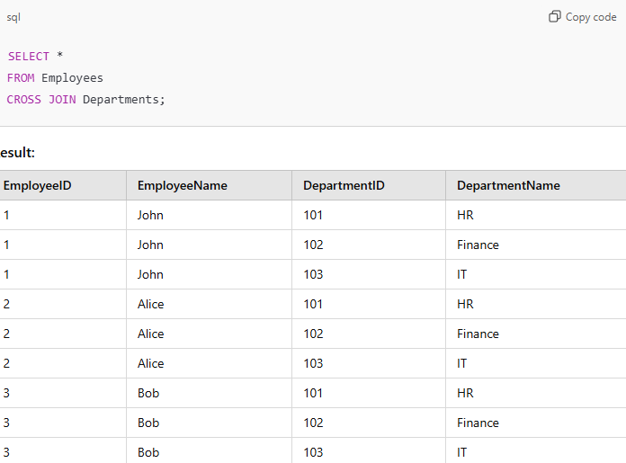

Explanation:
- Every row from the Employees table is paired with every row from the Departments table.
- Thus, the result set contains all possible combinations of employees and departments.
Considerations:
- A Cross Join can lead to very large result sets. Use it carefully with smaller datasets or filter conditions.
- To filter specific combinations, you can use WHERE or other JOIN types like INNER JOIN, LEFT JOIN, etc.

- Explain the concept of a foreign key relationship in databases.
A foreign key is a column or set of columns in one table that uniquely identifies rows in another table, establishing a link between them. It enforces referential integrity, ensuring that values in the foreign key column match primary key values in the referenced table. For example, an order_id in an orders table might be a foreign key in an order_details table, linking each detail to the corresponding order.
- What are composite keys? Give an example.
A composite key is a primary key that consists of two or more columns to uniquely identify a record in a table. Composite keys are useful when a single column is insufficient for uniqueness. For example, in a table recording student enrolments, a composite key could include both student_id and course_id to uniquely identify each enrolment record.

- How do you retrieve data from multiple tables without using JOINs?
Data from multiple tables can be retrieved without using JOINs by leveraging subqueries or using the UNION or UNION ALL operators. For example, using a subquery, you could select data from one table and use it in the WHERE clause of another. UNION combines result sets from two queries, requiring matching columns in each query.
Retrieving Data from Multiple Tables Without Using JOINs
Data from multiple tables can be retrieved using UNION, UNION ALL, or subqueries instead of JOINs. These methods combine the results of two or more queries into a single result set.
1. UNION Clause:
- Combines the result sets of two or more SELECT statements.
- Removes duplicate rows (by default).
- Columns in each SELECT statement must have the same data type.
2. UNION ALL Clause:
- Combines the result sets of two or more SELECT statements.
- Includes all rows, even duplicates.
Example Using UNION:
Tables:
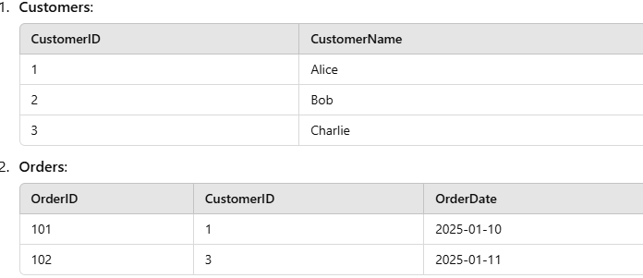
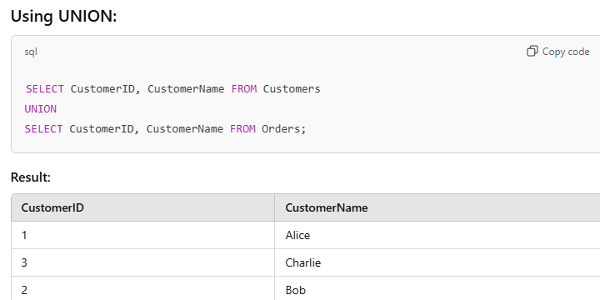
Explanation:
- The result combines customers and orders into a single set, removing duplicates (if any).
- In this case, only distinct customer IDs are shown.
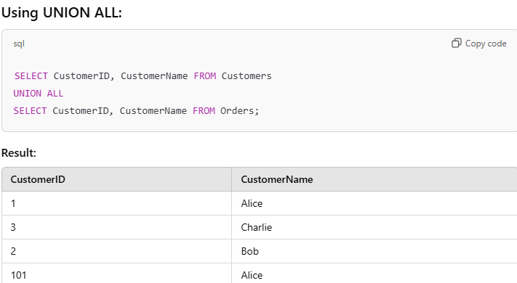
Explanation:
- Unlike UNION, UNION ALL retains all rows, including duplicates.
- Here, both tables provide distinct and overlapping results.

3. Subqueries and Nested Queries
- What is a subquery, and when would you use it?
A subquery, or nested query, is a query embedded within another SQL query. It is used to perform operations that require multiple steps, such as filtering data based on an aggregate function or checking for existence. Subqueries are particularly useful when you need to retrieve data based on the results of another query, enabling more complex queries without multiple JOINs.
- Explain the difference between correlated and non-correlated subqueries.
Non-Correlated Subquery: This type of subquery can be executed independently of the outer query. It returns a result that does not depend on any columns from the outer query. For example:
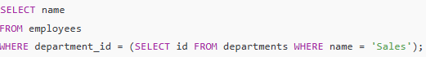
Correlated Subquery: This type of subquery refers to columns from the outer query and cannot be executed independently. It runs for each row processed by the outer query. For example:

SELECT name
FROM employees e
WHERE e. salary > (SELECT AVG (salary) FROM employees WHERE department_id = e. department_id);
- How can you use a subquery in the SELECT, FROM, WHERE, and HAVING clauses?

- What is an inline view?
An inline view is like a temporary table created by running a small query inside another query. It helps you do calculations or organize data before combining everything in the main query.

Simple Explanation with Example:
Imagine you want to find the average salary of employees in different departments. Instead of pulling everything from the main table and then calculating averages, you can create a temporary view (inline view) to do the calculation first.
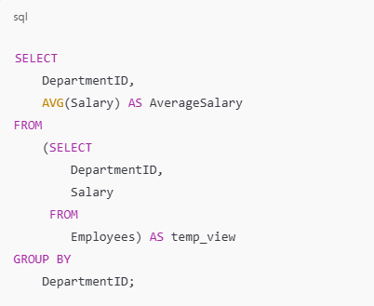
How it works:
- Inner Query:
  - Selects DepartmentID and Salary from the Employees table.
- Inline View:
  - The result of this inner query is used in the outer query like a temporary table (temp_view).
- Outer Query:
  - Groups the data by DepartmentID and calculates the average salary using AVG(Salary).
Simple Explanation:
- The inline view (temp_view) helps you break down the process by calculating salaries first.
- Then, the main query uses that result to calculate averages per department.
This makes complex queries easier and more efficient!

- How do you handle subqueries that return multiple rows?
When a subquery returns multiple rows, you can handle it in several ways:
- Using IN Operator: If you want to filter results based on the values returned, you can use the IN operator. Example:
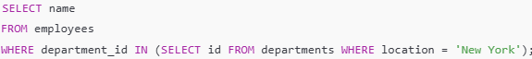
- Using EXISTS Operator: Use the EXISTS operator to check for the presence of rows returned by the subquery without needing the actual values. Example:
SELECT name FROM employees e
WHERE EXISTS (SELECT 1 FROM departments d WHERE d.id = e.department_id AND d.location = 'New York');

- Using ANY or ALL Operators: These operators allow you to compare a value against the set of values returned by the subquery. Example:
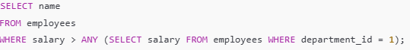

4. Advanced SQL Functions
- Explain aggregate functions (e.g., SUM, COUNT, AVG, MIN, MAX).
Aggregate functions are used to perform calculations on a set of values and return a single value. Common aggregate functions include:
- SUM (): Calculates the total sum of a numeric column.
  - Example: SELECT SUM (salary) FROM employees;
- COUNT (): Counts the number of rows in a dataset or counts non-null values in a column.
  - Example: SELECT COUNT (*) FROM employees;
- AVG (): Calculates the average value of a numeric column.
  - Example: SELECT AVG (salary) FROM employees;
- MIN (): Returns the smallest value in a set.
  - Example: SELECT MIN (salary) FROM employees;
- MAX (): Returns the largest value in a set.
  - Example: SELECT MAX (salary) FROM employees;

- What is the purpose of the CASE statement in SQL?
The CASE statement in SQL is a conditional expression that allows you to perform if-then logic directly in your queries. It can return different values based on specific conditions.
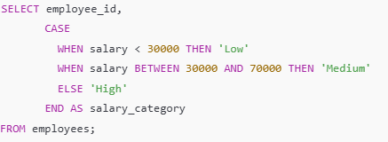
- Explain COALESCE and NULLIF functions.
COALESCE: Returns the first non-null value in a list of expressions. It’s useful for handling null values in data.
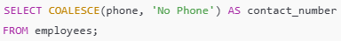
NULLIF (): Compares two expressions and returns NULL if they are equal; otherwise, it returns the first expression. This can prevent division by zero or avoid unwanted comparisons.
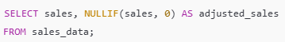
- How does the IFNULL or ISNULL function work?
IFNULL () (MySQL) or ISNULL () (SQL Server) are used to replace NULL values with a specified value.
- Example with IFNULL:
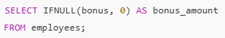

Example with ISNULL:
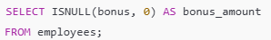

- Describe how you would use window functions like ROW_NUMBER (), RANK (), DENSE_RANK (), and NTILE ().
ROW_NUMBER (): Assigns a unique sequential integer to rows within a partition of a result set.
- Example:
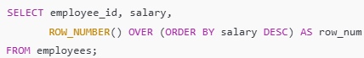
RANK (): Assigns a rank to each row within a partition, with gaps in the ranking when there are ties.
- Example:
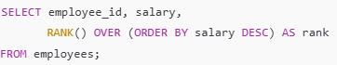
DENSE_RANK (): Similar to RANK (), but without gaps in the ranking.
- Example:
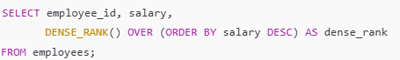
NTILE(n): Divides the result set into n buckets and assigns a bucket number to each row.
- Example:
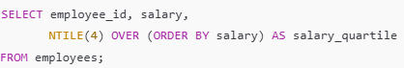

- Explain LEAD () and LAG () functions and give examples.
LEAD () and LAG () are window functions that allow you to access data from a subsequent or preceding row in the same result set.
LEAD (): Retrieves the value from the next row within the same result set.
- Example:
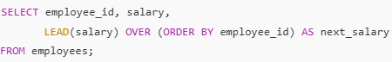
LAG (): Retrieves the value from the previous row within the same result set.
- Example:
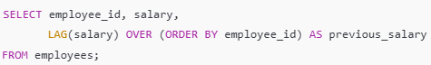
- What are CTEs (Common Table Expressions), and how do you use them?
Common Table Expressions (CTEs) are temporary result sets defined within the execution of a single SQL statement. They are often used for organizing complex queries and improving readability.
- Example:
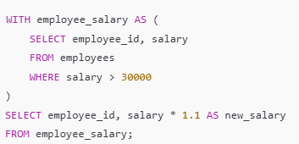
CTEs can also be recursive, allowing for hierarchical or iterative data queries, making them particularly useful for working with self-referential data like organizational charts.

5. Database Design and Normalization
- What is normalization, and why is it important?
Normalization is the process of organizing data in a database to minimize redundancy and dependency. It involves structuring the tables and relationships to ensure that each piece of data is stored only once.
Importance:
- Reduces Data Redundancy: By ensuring that each data element is stored only once, normalization helps eliminate duplicate data.
- Improves Data Integrity: Reducing redundancy minimizes the chances of data anomalies and inconsistencies.
- Facilitates Maintenance: With a well-structured database, updates, deletions, and insertions become easier and more reliable.
- Enhances Query Performance: Although normalization can sometimes slow down complex queries, it generally improves the performance of single-table queries.

- Describe the different normal forms (1NF, 2NF, 3NF, BCNF).
- First Normal Form (1NF):
  - A table is in 1NF if all columns contain atomic (indivisible) values, and each entry in a column is of the same data type.
  - Example: A table with a list of students where each student has a unique identifier and all their courses are stored in separate rows.
- Second Normal Form (2NF):
  - A table is in 2NF if it is in 1NF and all non-key attributes are fully functionally dependent on the primary key. This means that there should be no partial dependency of any column on a composite key.
  - Example: In a table with student IDs and course IDs as a composite key, if a column like "Instructor" depends only on "Course ID," the table should be split.
- Third Normal Form (3NF):
  - A table is in 3NF if it is in 2NF and all the attributes are only dependent on the primary key. No transitive dependencies should exist.
  - Example: If a table has a column for "Department Name" that depends on "Instructor," it should be separated into another table.
- Boyce-Codd Normal Form (BCNF):
  - A table is in BCNF if it is in 3NF and every determinant is a candidate key. This form addresses certain types of anomalies that 3NF does not.
  - Example: If a table has "Course" and "Instructor," and a specific instructor can only teach one course, it violates BCNF since "Instructor" can determine "Course" but is not a candidate key.

- What is denormalization, and when would you use it?
Denormalization is the process of deliberately introducing redundancy into a database by combining tables or adding redundant data. This can improve query performance by reducing the number of joins needed when retrieving data.
When to Use Denormalization:
- Read-Heavy Applications: In scenarios where read performance is critical (like data warehousing), denormalization can speed up queries.
- Simplifying Complex Queries: When queries become too complex due to many joins, denormalization can simplify these by reducing the number of tables involved.
- Improving Reporting Performance: In reporting systems where performance is prioritized over update integrity, denormalization can provide quicker access to necessary data.

- Explain the concept of a star schema and a snowflake schema in data warehousing.
- Star Schema:
  - A star schema is a simple database schema that consists of a central fact table surrounded by dimension tables. The fact table holds quantitative data (like sales), while dimension tables provide context (like date, product, and customer).
  - Advantages: Easier to understand and query; provides better performance due to fewer joins.
- Snowflake Schema:
  - A snowflake schema is a more complex version of the star schema where dimension tables are normalized into multiple related tables. For example, instead of having a single "Product" dimension, there might be separate tables for "Product" and "Category."
  - Advantages: Reduces data redundancy and saves storage space, but can complicate queries and slow down performance due to additional joins.

- What is a database index? How does indexing improve query performance?
A database index is a data structure that improves the speed of data retrieval operations on a database table at the cost of additional storage space and maintenance overhead.
How Indexing Improves Query Performance:
- Faster Search Operations: Indexes allow the database engine to find data quickly without scanning every row in a table.
- Efficient Sorting: Indexes can help the database quickly sort data based on indexed columns.
- Improved JOIN Performance: Indexes on join columns can significantly reduce the time taken to join tables.

- What are the types of indexes, and when would you use each?
• Unique Index: Ensures that all values in a column are distinct. Use when you need to enforce uniqueness (e.g., email addresses).
• Composite Index: An index on multiple columns. Use when queries frequently filter or sort on multiple columns.
• Full-Text Index: Designed for searching text data. Use in applications requiring advanced search capabilities, such as searching within a large body of text.
• Bitmap Index: Uses bit arrays and is useful for columns with a limited number of distinct values (e.g., gender). Use when performing complex queries on low-cardinality columns.
• Spatial Index: Optimizes the querying of spatial data (geographical data). Use when working with geographic data types for fast spatial queries.

What are table and Field?
Table: A table has a combination of rows and columns. Rows are called records and columns are called fields. In MS SQL Server, the tables are being designated within the database and schema names.
Field: In DBMS, a database field can be defined as – a single piece of information from a record
- What is normalization?
It is a process of analyzing the given relation schemas based on their functional dependencies and primary keys to achieve the following desirable properties:
- Minimizing Redundancy
- Minimizing the Insertion, Deletion, And Update Anomalies
Relation schemas that do not meet the properties are decomposed into smaller relation schemas that could meet desirable properties.
- What is Denormalization?
Denormalization is a database optimization technique in which we add redundant data to one or more tables. This can help us avoid costly joins in a relational database. Note that denormalization does not mean not doing normalization. It is an optimization technique that is applied after normalization.
In a traditional normalized database, we store data in separate logical tables and attempt to minimize redundant data. We may strive to have only one copy of each piece of data in the database.

- What is a clustered vs. non-clustered index?
• Clustered Index:
- A clustered index determines the physical order of data in a table. There can be only one clustered index per table because the rows can be sorted in only one way.
- Example: The primary key is typically implemented as a clustered index. When you retrieve data by the primary key, it's fast because the data is stored in order.
• Non-Clustered Index:
- A non-clustered index does not alter the physical order of the data. Instead, it creates a separate structure that points to the data rows. You can have multiple non-clustered indexes on a table.
- Example: Use a non-clustered index for columns that are frequently queried but are not primary keys, such as a column used in filtering conditions.

- What are the different operators available in SQL?
There are three operators available in SQL namely:
- Arithmetic Operators
- Logical Operators
- Comparison Operators

What is Data Integrity?
Data integrity is defined as the data contained in the database being both correct and consistent. For this purpose, the data stored in the database must satisfy certain types of procedures (rules). The data in a database must be correct and consistent. So, data stored in the database must satisfy certain types of procedures (rules). DBMS provides different ways to implement such types of constraints (rules). This improves data integrity in a database

- What is Collation in MySQL?
Collation in MySQL defines how text data is stored, sorted, and compared in a database. It determines how strings (text values) are treated when performing operations like sorting (ORDER BY) or searching (WHERE clause). Collation works together with character sets to handle text data.

6. Query Optimization and Performance Tuning
- How do you optimize SQL queries for better performance?
QL queries can be optimized for better performance by:
- Using Indexes: Create indexes on frequently used columns in WHERE clauses, JOIN conditions, or ORDER BY clauses.
- *Avoiding SELECT : Only retrieve the columns needed to reduce data retrieval time and memory usage.
- Optimizing Joins: Minimize the number of joins or join only necessary tables, and use proper join conditions.
- Using WHERE Clauses on Filtered Rows Early: Filtering data early in the query process can reduce the amount of data processed.
- Limiting Subqueries and Using JOINS Where Possible: Using joins instead of subqueries can improve readability and often performance.
- Avoiding Functions on Indexed Columns: Applying functions on indexed columns can negate the index, so avoid functions in WHERE clauses for indexed columns.

- What is an execution plan, and how do you read it?
An execution plan shows the steps a database engine takes to execute a SQL query. By analyzing an execution plan, you can understand the query’s performance, such as the order of table scans, join operations, and index usage. To read it:
- Look for Table Scans vs. Index Scans: Full table scans are generally slower; index scans are more efficient.
- Examine Join Methods: Nested loops and hash joins have different performance impacts, depending on data volume.
- Check Cost Estimates: Costs assigned to each operation can indicate bottlenecks. Execution plans are commonly generated using the EXPLAIN keyword before a query, providing insights to optimize performance.

- What are the different types of SQL indexes, and how do they affect performance?
• Primary Index (Clustered Index): Orders table data based on primary key columns. Speeds up data retrieval by ordering data physically, but slows down insertions or updates due to reordering.
• Non-Clustered Index: A separate structure that points to the actual data. These are efficient for quick lookups but add overhead on insertions and updates.
• Unique Index: Enforces unique values on columns, preventing duplicate entries and improving search speed on unique columns.
• Composite Index: An index on multiple columns, useful when multiple columns are used together in queries. Indexes improve read performance but can slow down write operations due to the need for index maintenance.
- How do joins affect query performance?
Joins impact query performance based on the type and amount of data involved:
- Inner Joins are usually faster than outer joins as they filter out non-matching rows.
- Left, Right, and Full Joins can be more costly because they retrieve unmatched rows as well, increasing data processed.
- Cross Joins are the most expensive, generating a Cartesian product, and should be used carefully. Large datasets and complex joins may lead to slower performance, so indexing on join columns and using filters can help optimize.

- Explain query caching and its importance.
Query caching stores the results of frequently executed queries, reducing database load and improving performance for repeated queries. When a query is cached, subsequent identical queries retrieve the result from the cache rather than re-executing the query. Query caching is particularly useful for read-heavy applications, as it reduces CPU and memory usage and improves response time.
- What is a database partition, and when would you use it?
Database partitioning divides a large table into smaller, more manageable pieces, often based on a key like date or region. This improves query performance by limiting the amount of data scanned. Partitioning is useful for large tables in scenarios like time-series data where queries only need specific partitions, reducing query processing time and improving database manageability.
- Describe the importance of indexing in SQL.
Indexing is crucial in SQL for improving query performance by allowing faster data retrieval. Indexes create a sorted structure that the database engine can scan more quickly, reducing the need for full table scans. This is particularly beneficial for SELECT queries on large datasets, but it’s essential to balance indexing with the potential impact on insert, update, and delete operations, which can slow down due to index maintenance.

- How can EXPLAIN be used to analyze and improve query performance?
The EXPLAIN command provides a breakdown of how a query is executed, showing details like table access methods, join types, index usage, and row counts. By analyzing the execution plan with EXPLAIN, you can:
- Identify Missing Indexes: If a table scan is used where an index scan would be faster.
- Optimize Joins: Check if nested loop joins are causing slowdowns and consider indexing or reordering.
- Reduce Query Cost: Focus on high-cost operations and make adjustments to reduce total query cost, such as adding filters or simplifying joins. Using EXPLAIN iteratively helps refine and optimize query performance.

7. Transactions and Concurrency Control
- What is a transaction in SQL, and why is it important?
A transaction in SQL is a sequence of operations that are treated as a single unit, meaning they are either fully completed or fully rolled back. Transactions ensure data integrity by grouping a set of operations, so if any part of the transaction fails, all changes are undone, leaving the database in a consistent state. Transactions are crucial for maintaining accuracy and consistency, especially in environments with multiple concurrent users.
- Explain ACID properties in the context of databases.
ACID properties ensure reliable transactions in databases:
- Atomicity: Ensures all operations within a transaction are completed successfully; if not, the transaction is rolled back.
- Consistency: Guarantees that the database transitions from one valid state to another, maintaining data integrity.
- Isolation: Ensures transactions are processed independently, so intermediate states are not visible to other transactions.
- Durability: Once a transaction is committed, changes are permanent, even in the event of system failures. Together, ACID properties make transactions dependable and prevent data corruption.

- What is the purpose of BEGIN, COMMIT, and ROLLBACK statements?
• BEGIN (or START): Marks the beginning of a transaction.
• COMMIT: Saves the changes made by the transaction to the database permanently.
• ROLLBACK: Reverts any changes made during the transaction, bringing the database back to its initial state before the transaction began. These commands are essential for managing transactions, allowing users to confirm or discard changes based on success or failure.
- What are the different isolation levels, and how do they impact transactions?
Isolation levels determine how transaction operations are isolated from each other, impacting data consistency and concurrency. The main levels are:
- Read Uncommitted: Transactions can see uncommitted changes from other transactions, leading to "dirty reads." Fast but least safe.
- Read Committed: Only committed data is read, preventing dirty reads but allowing non-repeatable reads (data might change if reread).
- Repeatable Read: Ensures that once data is read, it remains consistent during the transaction, preventing dirty and non-repeatable reads, but phantom reads can still occur.
- Serializable: The highest level, which prevents dirty, non-repeatable, and phantom reads by fully isolating transactions. This is safest but can slow down performance. Choosing the right isolation level balances performance and data accuracy, depending on the application requirements.

- Explain the difference between LOCK and NOLOCK.
• LOCK: This mechanism restricts access to a specific resource, ensuring that only one transaction can modify or read it until the lock is released, which prevents data inconsistencies.
• NOLOCK: Allows reading data without waiting for locks to be released, potentially improving performance but at the risk of reading uncommitted or "dirty" data. NOLOCK is commonly used in read-heavy scenarios where data changes infrequently, while LOCK is critical for ensuring data consistency in write-heavy or transactionally complex environments.
- What is deadlock in a database? How would you prevent it?
Deadlock occurs when two or more transactions hold locks on resources and wait indefinitely for each other’s locked resources, creating a circular dependency. Preventing deadlocks involves:
- Lock Ordering: Ensuring transactions request locks in a consistent order.
- Timeouts: Setting a timeout so that transactions automatically abort if they wait too long for a lock.
- Reducing Transaction Scope: Keeping transactions as short as possible to minimize the time resources are locked. Database systems also detect and resolve deadlocks by aborting one of the transactions, rolling it back, and allowing others to proceed.

- Describe optimistic vs. pessimistic locking.
• Optimistic Locking: Assumes that data conflicts are rare. A transaction proceeds without locking resources and checks for conflicts before committing. If a conflict is detected, the transaction is retried or aborted. Optimistic locking is efficient in read-heavy or low-contention environments.
• Pessimistic Locking: Assumes conflicts are likely, so locks are acquired at the beginning of a transaction, blocking other transactions from accessing the resource until the lock is released. This is suitable for high-contention environments or critical data updates where consistency is a priority. Choosing between these depends on the application’s requirements, data access patterns, and acceptable levels of concurrency.
8. Data Manipulation Techniques
- How do you delete duplicate rows in a table?
In SQL, there are multiple ways to delete duplicate rows depending on the SQL database you're using and your specific requirements. Here are some common methods:
1. Using ROW_NUMBER () with Common Table Expressions (CTE)
The ROW_NUMBER () function is commonly used to assign a unique row number to duplicate rows, making it easy to identify and delete them.
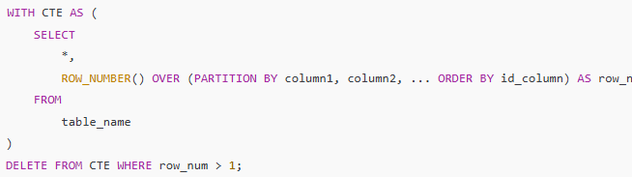
In this example:
- Replace column1, column2, ... with the columns that define duplicate rows.
- id_column can be any column used to determine which duplicate to keep (e.g., the latest entry).
- This query keeps only the first instance of each duplicate row and deletes the rest.

2. Using DELETE with JOIN
You can also use DELETE with JOIN to identify and remove duplicate rows.
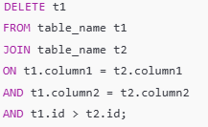
In this example:
- column1 and column2 define duplicate rows.
- t1.id > t2.id ensures that only the duplicate rows with a higher id are deleted, leaving one instance.

3. Using DELETE with Subquery
This method uses a subquery to delete duplicates based on the minimum or maximum ID.
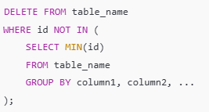
Here:
- Replace column1, column2, ... with the columns defining duplicate rows.
- This keeps the row with the smallest id for each group of duplicates.

4. Using GROUP BY with HAVING and DELETE
Some SQL databases allow deletion with GROUP BY and HAVING, where you identify duplicate groups and delete them.
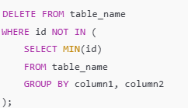

- How would you update data in one table based on data in another table?
To update data in one table based on data from another, you can use a JOIN in an UPDATE statement. Here’s an example:
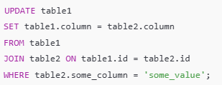
- How do you swap values in SQL between two rows in a single column?
To swap values between two rows in a column, you can use an UPDATE with conditional logic. Here’s an example:
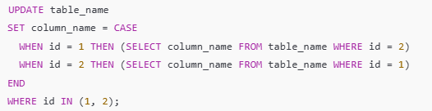
- Explain how to use the MERGE statement in SQL.
The MERGE statement allows you to perform insert, update, or delete operations in a target table based on the result of a join with a source table. Here’s the basic syntax:
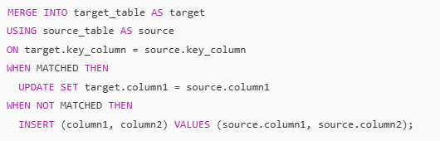
- How would you delete rows in a table with a complex condition?
To delete rows with a complex condition, use a DELETE statement with a WHERE clause that specifies the condition. If multiple conditions are needed, combine them with AND/OR. For example:
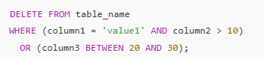
- How would you insert data into one table from another table?
9. Window Functions and Analytical Queries
- What are window functions in SQL, and when would you use them?
Window functions perform calculations across a set of table rows related to the current row, without collapsing rows into a single result. They are useful for complex analytics, like ranking, cumulative totals, and moving averages. Unlike aggregation functions, window functions don’t group rows; instead, they allow you to see row-specific data along with aggregate calculations.
- Explain the difference between ROW_NUMBER, RANK, and DENSE_RANK.
• ROW_NUMBER: Assigns a unique sequential number to each row within a partition, starting from 1. No gaps are created even if values are identical.
• RANK: Assigns a rank to rows within a partition with the same value, giving them the same rank and leaving gaps in rank numbers where duplicates occur.
• DENSE_RANK: Similar to RANK, but without gaps. Identical values get the same rank, and subsequent ranks continue in sequence.
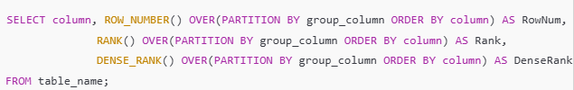
- How do you calculate a running total in SQL?
To calculate a running total, use the SUM () function as a window function with ORDER BY. Here’s an example:
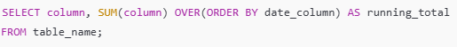
This generates a cumulative sum for each row based on the order specified, allowing you to see a running total up to each point.
- Explain how to calculate a moving average in SQL.
A moving average can be calculated using the AVG () window function along with ROWS BETWEEN. Here’s an example of a 3-row moving average:
SELECT column, AVG (column) OVER (ORDER BY date_column ROWS BETWEEN 2 PRECEDING AND CURRENT ROW) AS moving_avg
FROM table_name;
- How does the PARTITION BY clause work in window functions?
PARTITION BY divides the dataset into partitions based on specified columns, allowing window functions to be applied independently within each partition. This is helpful for performing calculations like ranking or cumulative totals for specific groups.
SELECT column, SUM (column) OVER (PARTITION BY category_column ORDER BY date_column) AS partitioned_total
FROM table_name;
- Give examples of using window functions for analytical tasks.
Window functions are widely used for tasks like:
- Ranking Top-N items per category: Using ROW_NUMBER () or RANK () to select the top results within each category.
- Calculating Cumulative Totals: Using SUM () for running totals over sales or metrics.
- Finding Moving Averages: Using AVG () with a window frame to smooth data trends.
- Percentile Calculations: Using PERCENT_RANK () or NTILE () to assign percentile ranks or divide data into quantiles.
SELECT category_column, column,
ROW_NUMBER () OVER (PARTITION BY category_column ORDER BY column DESC) AS row_num,
SUM (column) OVER (PARTITION BY category_column ORDER BY date_column) AS cumulative_total,
AVG (column) OVER (ORDER BY date_column ROWS BETWEEN 2 PRECEDING AND CURRENT ROW) AS moving_avg
FROM table_name;
10. Views, Triggers, and Stored Procedures
- What is a view in SQL? How is it different from a table?
A view is a virtual table in SQL that is defined by a SELECT query. Unlike a table, a view doesn’t store data; it dynamically retrieves data from underlying tables whenever accessed. Views can simplify complex queries, enhance security by restricting access to specific columns, and help present data in a more understandable format without altering the underlying tables.
- What are the advantages of using views?
Views offer several benefits:
- Simplicity: Simplify complex queries by saving them as reusable views.
- Security: Restrict access to sensitive data by exposing only selected columns or rows.
- Data Abstraction: Hide underlying table structures and provide a tailored view of data.
- Data Consistency: Centralize calculations or transformations in a view, ensuring consistency across applications that use the view.

- Explain what triggers are in SQL and provide an example use case.
: Triggers are special SQL commands that automatically execute specified actions in response to certain events on a table, like INSERT, UPDATE, or DELETE. For example, a trigger can automatically log data changes to a history table whenever a record is updated in the main table. A use case might be auditing changes to an employee table:
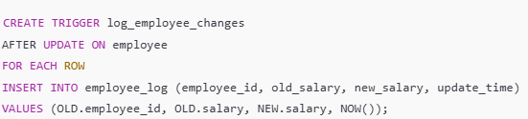
- What are stored procedures, and why are they useful?
Stored procedures are precompiled collections of SQL statements stored in the database, which can be executed by calling the procedure’s name. They are useful for encapsulating complex logic, improving performance (due to precompilation), reducing network traffic, and enhancing code reusability. Stored procedures also centralize logic, making it easier to maintain and update.
- Explain the difference between stored procedures and functions.
Stored procedures are precompiled collections of SQL statements stored in the database, which can be executed by calling the procedure’s name. They are useful for encapsulating complex logic, improving performance (due to precompilation), reducing network traffic, and enhancing code reusability. Stored procedures also centralize logic, making it easier to maintain and update.
- How do you create and call a stored procedure in SQL?
• Stored Procedures: Can perform multiple operations, including modifying data. They do not necessarily return a value and can have multiple output parameters.
• Functions: Generally designed to return a single value and are often used in calculations or queries. They cannot modify database data, except for certain read-only operations. Functions are typically used within SELECT statements, while procedures are used as standalone calls to perform more extensive tasks.

- Explain the purpose of AFTER and BEFORE triggers.
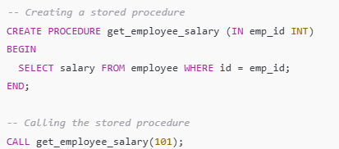
In this example, the procedure get_employee_salary retrieves the salary of an employee based on their emp_id.
11. Data Extraction, Transformation, and Loading (ETL)
- Explain the ETL process and its importance in data science.
ETL stands for Extract, Transform, Load—a data integration process essential for consolidating and preparing data for analysis. In data science, ETL is critical because it enables the collection of data from various sources (Extract), applies data transformations for consistency and accuracy (Transform), and loads clean data into a data warehouse or analysis-ready environment (Load). This process ensures that data used in modeling and analytics is accurate, relevant, and accessible.
- How do you extract data from multiple sources using SQL?
SQL can extract data from multiple sources by using database links to connect across different databases or through ETL tools that support SQL-based data extraction. Additionally, UNION and JOIN statements help combine data from tables within the same database. For instance:
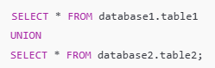
- Describe techniques to transform data using SQL.
SQL provides several functions and clauses for data transformation:
- Data Type Conversion: Using CAST() or CONVERT() to change data types.
- Data Aggregation: Using SUM(), AVG(), COUNT(), MIN(), and MAX() to summarize data.
- String Manipulation: Using functions like CONCAT(), UPPER(), LOWER(), and TRIM() for text transformation.
- Conditional Logic: Using CASE statements to create new columns or conditional values.
- Date and Time Calculations: Using DATEADD(), DATEDIFF(), and other date functions to manipulate date values. For example, using CASE to create categories:
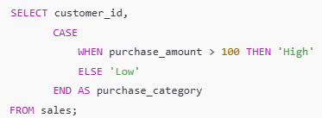
- How would you use SQL to clean and prepare data?
Data cleaning with SQL involves identifying and handling inconsistencies and preparing the data for analysis:
- Removing Duplicates: Using DELETE with ROW_NUMBER () or DISTINCT to eliminate duplicate rows.
- Handling Missing Values: Replacing NULL values with defaults using COALESCE () or updating specific fields.
- Outlier Detection: Using conditional filtering to flag or remove extreme values.
- Standardizing Data: Using string functions to correct format inconsistencies, e.g., UPPER () to standardize text case.
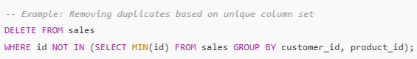

- How can SQL be used in data integration processes?
SQL plays a central role in data integration by helping merge, consolidate, and harmonize data from disparate sources:
- JOINs: Combine tables within the same database, integrating data across different structures.
- UNION: Aggregate data from similar tables across databases.
- Subqueries and Common Table Expressions (CTEs): Create modular queries to build complex transformations.
- ETL Tools Integration: SQL is often used within ETL tools (e.g., Apache Nifi, Talend) that pull data from multiple sources and allow for SQL-based transformations.
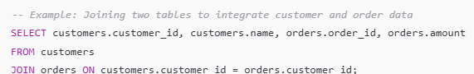
12. Database Security
- What are roles and permissions in SQL?
In SQL, roles are named sets of permissions that can be assigned to users or groups of users. They simplify the management of access rights by allowing administrators to define a role with specific permissions (like SELECT, INSERT, UPDATE, and DELETE) and then assign that role to multiple users. This way, if a user's permissions need to change, the administrator can adjust the role rather than individual user permissions. Permissions are the rights assigned to roles or users that dictate what actions can be performed on database objects (e.g., tables, views, procedures).
- How would you grant and revoke permissions on tables?
You can use the GRANT and REVOKE commands to manage permissions in SQL. For example, to grant a user the ability to select and insert data in a table:
To revoke those permissions, you would use: sql REVOKE SELECT, INSERT ON table_name FROM user_name; This mechanism allows for fine-grained control over who can perform specific actions on database objects.
- Explain the concept of database views for security purposes.
Database views act as virtual tables that present data from one or more tables while restricting direct access to the underlying tables. By using views, administrators can provide users with access to specific data subsets without exposing the entire table. This enhances security by:
- Limiting data exposure: Users can only see what is included in the view, such as specific columns or rows that meet certain criteria.
- Simplifying complex queries: Views can encapsulate complex joins and aggregations, presenting a simplified interface to users.
- Enforcing row-level security: Views can be designed to filter data based on user attributes or roles, ensuring that users only access data pertinent to them.

- What is SQL injection, and how do you prevent it?
SQL injection is a code injection technique where an attacker manipulates SQL queries by inserting malicious code into input fields, potentially gaining unauthorized access to data or executing harmful commands. To prevent SQL injection, you can:
- Use Prepared Statements: These separate SQL code from data, making it impossible for attackers to alter the query structure.
- Parameterized Queries: These ensure that user input is treated as data rather than part of the SQL command.
- Input Validation: Validate and sanitize user inputs, ensuring they conform to expected formats.
- Limit Database Permissions: Reduce the privileges of database users to limit the impact of a successful injection.

- How does row-level security work in databases?
Row-level security (RLS) is a feature that restricts data access at the row level based on the characteristics of the user executing the query. RLS allows you to define policies that determine which rows are visible to which users. For example:
- User Context: Policies can filter rows based on user roles or attributes, ensuring that users only see rows relevant to them.
- Dynamic Filtering: RLS can apply conditions dynamically, modifying the results of queries based on the user executing them. This enhances security and compliance by ensuring sensitive data is not exposed to unauthorized users while still allowing users to access data they are permitted to see.

13. NoSQL and Big Data Concepts
- What is NoSQL, and how is it different from SQL databases?
NoSQL, or "Not Only SQL," refers to a category of database management systems that provide a mechanism for storage and retrieval of data that is modeled in means other than the tabular relations used in SQL databases. The key differences are:
- Data Model: SQL databases use structured data with a fixed schema and tables, whereas NoSQL databases can store unstructured or semi-structured data in various formats like JSON, XML, or key-value pairs.
- Scalability: NoSQL databases are designed to scale horizontally across many servers, making them suitable for large-scale applications, while SQL databases typically scale vertically (adding more power to a single server).
- Flexibility: NoSQL allows for dynamic schemas, meaning fields can be added or modified without needing to alter existing data, which is more rigid in SQL databases.

- Explain the main types of NoSQL databases (key-value, document, column-family, and graph).
The main types of NoSQL databases include:
- Key-Value Databases: These store data as a collection of key-value pairs. Each key is unique, and values can be simple objects or complex data structures (e.g., Redis, DynamoDB).
- Document Databases: These store data in documents (often JSON or BSON format), allowing for nested structures and rich querying. They are ideal for semi-structured data (e.g., MongoDB, CouchDB).
- Column-Family Databases: These store data in columns rather than rows, which can improve performance for certain types of queries. They are often used in analytics applications (e.g., Apache Cassandra, HBase).
- Graph Databases: These are designed to represent and query relationships between data points. They use graph structures with nodes and edges, making them suitable for applications like social networks and recommendation engines (e.g., Neo4j, Amazon Neptune).

- What are some benefits and limitations of NoSQL databases?
• Benefits:
- Scalability: NoSQL databases can easily scale out to handle large volumes of data and high traffic.
- Flexibility: They support various data models and schemas, making them adaptable to changing application requirements.
- Performance: They can deliver high performance for specific workloads, particularly for read and write operations on large datasets.
• Limitations:
- Complexity: Managing multiple NoSQL databases can introduce complexity, as there are different technologies and paradigms to understand.
- Consistency: Many NoSQL databases Favor eventual consistency over strict ACID transactions, which can lead to challenges in maintaining data integrity.
- Limited Query Capabilities: NoSQL databases may not support complex queries as efficiently as SQL databases, limiting their use in certain analytical applications.

- When would you choose a SQL database over a NoSQL database?
You would typically choose a SQL database when:
- Data Integrity: Strong consistency and ACID compliance are critical, such as in financial applications or systems that require reliable transactions.
- Complex Queries: The application requires complex joins, aggregations, and relational queries, which SQL databases handle efficiently.
- Structured Data: The data is highly structured with a fixed schema that is unlikely to change over time.
- Mature Ecosystem: There is a need for mature tools and frameworks, as SQL databases have a long-standing history and robust ecosystems.

- How does SQL interact with Big Data technologies like Hadoop and Spark?
14. Practical SQL Scenarios and Case Studies
- How would you find the second-highest salary in an employee table?
To find the second-highest salary, you can use the DISTINCT keyword along with the LIMIT clause (or OFFSET depending on the SQL dialect). Here's an example query:
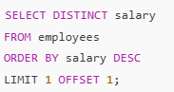
- Write a query to find duplicate records in a table.
To find duplicate records based on specific columns, you can use the GROUP BY clause and the HAVING clause. Here’s an example:
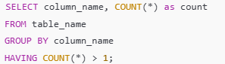
- How would you get the most recent order for each customer in a table?
You can use a common table expression (CTE) or a subquery with a ROW_NUMBER () window function to achieve this. Here’s an example using ROW_NUMBER ():
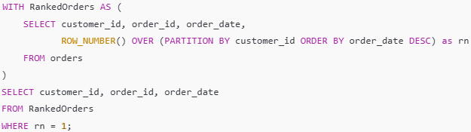
- How would you retrieve employees who joined on the same date?
To find employees who joined on the same date, you can use a GROUP BY clause with a HAVING clause to filter those dates with more than one employee. Here’s a query:
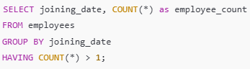
- Write a query to get the cumulative sales by month for each product.
To calculate cumulative sales by month for each product, you can use the SUM () function as a window function. Here's an example:
SELECT product_id,
DATE_TRUNC ('month', order_date) as sales_month,
SUM (sales_amount) OVER (PARTITION BY product_id ORDER BY DATE_TRUNC ('month', order_date) ROWS BETWEEN UNBOUNDED PRECEDING AND CURRENT ROW) as cumulative_sales
FROM sales ORDER BY product_id, sales_month;
- How would you calculate the percentage of total sales by product?
To calculate the percentage of total sales by product, you can use the SUM () function along with a subquery to get the total sales. Here’s an example query:
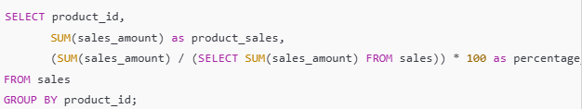
This query calculates the sales for each product and divides it by the total sales to find the percentage, displaying it for each product.
15. SQL and Data Science Applications
- How is SQL used in data preprocessing for machine learning?
SQL is commonly used in data preprocessing for machine learning by allowing data scientists to perform essential operations such as data cleaning, transformation, and aggregation directly in the database. For example, SQL can help identify and remove duplicates, handle missing values with techniques like imputation or filtering, and create new features through calculations or aggregations. SQL queries can also be used to join multiple tables, which is crucial for creating a comprehensive dataset for training machine learning models. Overall, SQL provides an efficient way to prepare large datasets before further processing in machine learning frameworks.
- How would you use SQL to sample data?
To sample data in SQL, you can use the TABLESAMPLE clause or the ORDER BY clause with LIMIT. For example, if you want a random sample of 100 rows from a table:
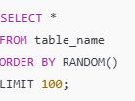
Alternatively, for SQL databases that support TABLESAMPLE, you might use:
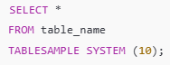
This will return approximately 10% of the table's rows, depending on the specific implementation and configuration.
- Explain how you can use SQL for data exploration.
SQL is a powerful tool for data exploration, allowing data scientists to quickly understand the structure and contents of a dataset. Common SQL commands used for exploration include:
- SELECT statements to view specific columns or the first few rows of data.
- COUNT () and GROUP BY to summarize data and get counts of unique values.
- DESCRIBE or SHOW COLUMNS to understand the schema and data types.
- Aggregate functions like SUM (), AVG (), and MAX () to get insights into numerical data. By executing these queries, you can identify trends, spot anomalies, and better understand the relationships within your data, which are crucial for guiding further analysis or modeling decisions.

- What are some SQL best practices for working with large datasets?
When working with large datasets in SQL, it's important to follow best practices to ensure performance and maintainability:
- Use indexing to speed up query performance on frequently accessed columns.
- Limit data retrieval by using SELECT statements that specify only the necessary columns instead of using SELECT *.
- Implement pagination or use LIMIT to process large result sets in smaller chunks.
- Avoid complex joins, when possible, as they can significantly slow down queries; instead, try to denormalize data if feasible.
- Regularly analyze and optimize queries using execution plans to identify bottlenecks and improve efficiency.
- Use partitioning for tables when dealing with extremely large datasets to improve performance on queries and maintenance.

- Describe how SQL can be integrated into Python or R for data science tasks.
- SQL can be easily integrated into Python and R, enabling data scientists to leverage the strengths of both programming languages and SQL databases. In Python, libraries like pandas with pandas.read_sql() or SQL Alchemy can be used to execute SQL queries and load the results into Data Frames for analysis. Additionally, the sqlite3 module allows for working with SQLite databases directly.
In R, the DBI package along with RMySQL, RSQLite, or odbc enables connection to various databases. You can use functions like dbGetQuery() to execute SQL commands and import data into R for analysis or modeling.
By combining SQL with these languages, you can efficiently manipulate and analyze large datasets stored in relational databases, facilitating tasks such as data cleaning, feature engineering, and exploratory data analysis.

ALL THE FUNCTIONS OF SQL & SYNTAX
- COUNT (): Counts the number of rows.
- SUM (): Adds up values in a column.
- AVG (): Calculates the average value.
- MIN (): Returns the smallest value in a column.
- MAX (): Returns the largest value in a column.
- GROUP_CONCAT (): Concatenates values from multiple rows into a single string (MySQL specific).
2. String Functions
- CONCAT (): Combines multiple strings into one.
- SUBSTRING () or SUBSTR (): Extracts a portion of a string.
- UPPER (), LOWER (): Converts text to uppercase or lowercase.
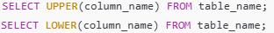
- LENGTH () or LEN (): Returns the length of a string.
- TRIM (), LTRIM (), RTRIM (): Removes whitespace from a string.
- REPLACE (): Replaces occurrences of a substring within a string.
- CHARINDEX () or INSTR (): Finds the position of a substring within a string.
- LEFT (), RIGHT (): Extracts characters from the left or right of a string.
- REVERSE (): Reverses the characters in a string.
3. Date and Time Functions
- NOW (): Returns the current date and time.
- CURDATE (), CURRENT_DATE: Returns the current date.
- CURTIME (), CURRENT_TIME: Returns the current time.

- DATE (): Extracts the date part from a datetime value.
- TIME (): Extracts the time part from a datetime value.
- DATEDIFF (): Calculates the difference between two dates.
- DATEADD (), ADD_DATE (): Adds a specified interval to a date.
- DATE_SUB (), SUBDATE (): Subtracts a specified interval from a date.
- YEAR (), MONTH (), DAY (): Extracts year, month, or day from a date.
- HOUR (), MINUTE (), SECOND (): Extracts hour, minute, or second from a time.
- STRFTIME (): Formats a date according to the specified format.
- DATE_FORMAT: The DATE_FORMAT function in SQL is used to format date values into a specified format.
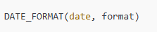
4. Mathematical Functions
- ABS (): Returns the absolute value of a number.
- ROUND (): Rounds a number to the specified number of decimal places.
- CEIL () or CEILING (): Rounds a number up to the nearest integer.
- FLOOR (): Rounds a number down to the nearest integer.
- POWER (): Raises a number to a specified power.
- SQRT (): Returns the square root of a number.
- RAND (): Generates a random number.
- EXP (): Returns e raised to the power of a specified number.
- LOG (): Returns the natural logarithm of a number.
5. Conditional Functions
- CASE: A conditional expression to return different values based on conditions.
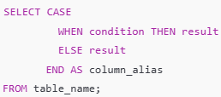
- IF () (MySQL): Returns one value if a condition is true and another if it is false.
- NULLIF (): Returns NULL if two expressions are equal, otherwise returns the first expression.
- COALESCE (): Returns the first non-NULL value in a list.
- ISNULL (), IFNULL (): Checks if a value is NULL and returns a specified value if it is.
6. Window and Ranking Functions
- ROW_NUMBER (): Assigns a unique row number within a partition of a result set.
SELECT ROW_NUMBER () OVER (PARTITION BY column_name ORDER BY column_name) AS row_num FROM table_name;
- RANK (): Assigns a rank to each row within a partition, with gaps in ranking for ties.
SELECT RANK () OVER (PARTITION BY column_name ORDER BY column_name) AS rank FROM table_name;
- DENSE_RANK (): Assigns ranks without gaps.
- NTILE (): Divides rows into a specified number of groups.
- LEAD (): Accesses data from the following row within the result set.
SELECT LEAD (column_name, offset, default_value) OVER (ORDER BY column_name) FROM table_name;
- LAG (): Accesses data from the previous row within the result set.
SELECT LAG (column_name, offset, default_value) OVER (ORDER BY column_name) FROM table_name;
- FIRST_VALUE (): Returns the first value in an ordered partition.
- LAST_VALUE (): Returns the last value in an ordered partition.
7. Conversion Functions
- CAST (): Converts a value from one data type to another.
- CONVERT (): Converts a value from one data type to another (specific to some SQL dialects).
- TO_DATE (): Converts a string to a date format.
- TO_CHAR (): Converts a date or number to a string.
- TO_NUMBER (): Converts a string to a number.
8. Data Manipulation Functions
- INSERT INTO: Adds new records to a table.
- UPDATE: Modifies existing records in a table.
- DELETE: Removes records from a table.
- MERGE: Combines INSERT and UPDATE based on conditions.
- TRUNCATE: Deletes all records from a table without logging individual row deletions.
9. Utility Functions
- DATABASE (): Returns the name of the current database.
- VERSION (): Returns the database version.
- USER (): Returns the current user.
- SESSION_USER (): Returns the session user.
- SYSTEM_USER (): Returns the system user.
- CURRENT_SCHEMA (): Returns the name of the current schema.
10. JSON Functions (for JSON Data)
- JSON_OBJECT (): Creates a JSON object.
- JSON_ARRAY (): Creates a JSON array.
- JSON_EXTRACT (): Extracts data from a JSON document.
- JSON_UNQUOTE (): Unquotes a JSON value.
- JSON_INSERT (): Inserts data into a JSON document.
- JSON_REMOVE (): Removes data from a JSON document.
- JSON_SET (): Modifies data in a JSON document.
11. Indexing and Partitioning Functions
- CREATE INDEX: Creates an index on a table.
- ALTER INDEX: Modifies an index.
- DROP INDEX: Deletes an index.
- PARTITION BY: Partitions data into different segments, often used in window functions.
- CREATE PARTITION: Creates partitions in a database.
12. Full-Text Search Functions (Some SQL Dialects)
- MATCH (): Used with AGAINST () in MySQL for full-text searching.
- CONTAINS (): Used in SQL Server for full-text search.
- FREETEXT (): Searches for the meaning of words rather than exact phrases.

When using SUM with CASE, you don’t need the 0 at the end; simply close the CASE expression

FRAME CLAUSE
In SQL, the FRAME clause is part of the OVER clause in window functions, used to define a specific subset of rows for calculations. It determines the "window frame" or the set of rows to include in the computation for each row.
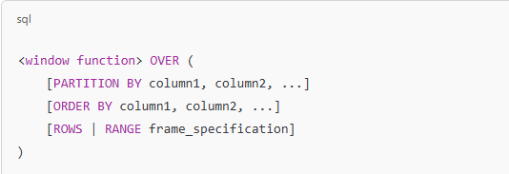
Key Components of the FRAME Clause
- ROWS vs. RANGE:
  - ROWS: Defines the frame based on the physical number of rows relative to the current row.
  - RANGE: Defines the frame based on the logical values of the columns, typically from the ORDER BY clause.
- Frame Specification Options:
  - UNBOUNDED PRECEDING: Includes all rows from the start of the partition to the current row.
  - UNBOUNDED FOLLOWING: Includes all rows from the current row to the end of the partition.
  - CURRENT ROW: Includes only the current row.
  - n PRECEDING: Includes the last n rows relative to the current row.
  - n FOLLOWING: Includes the next n rows relative to the current row.
- Exclusion Options:
  - EXCLUDE CURRENT ROW: Excludes the current row.
  - EXCLUDE GROUP: Excludes the current group of rows.
  - EXCLUDE TIES: Excludes rows that are tied with the current row based on the ORDER BY clause.
  - EXCLUDE NO OTHERS: Includes all rows (default behavior).

Examples
1. ROWS Frame:
Calculate a running total of sales for the last 3 rows:
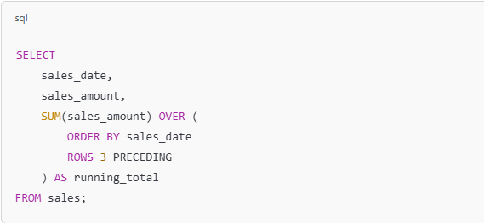
- Includes the current row and the 3 preceding rows.
2. RANGE Frame:
Calculate a cumulative total of sales up to the current day:
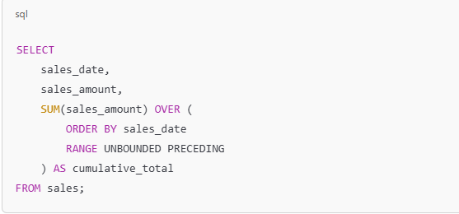
- Includes all rows with a sales_date less than or equal to the current row.
3. CURRENT ROW with ROWS:
Find a rolling average including the current row and the next row:
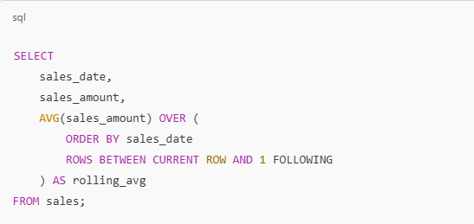
When to Use ROWS vs. RANGE
- Use ROWS: When working with absolute row positions, such as "last 3 rows."
- Use RANGE: When working with logical values or ranges, such as "all rows with the same timestamp or value."

Practical Use Cases
- Running Totals: Calculating cumulative metrics over time.
- Moving Averages: Calculating smoothed averages for trends.
- Rank Calculations: Using RANK() or ROW_NUMBER() with custom frames.
- Percentile Calculations: Using PERCENT_RANK() or NTILE() for distributions.
The FRAME clause enhances the flexibility of SQL window functions, making it indispensable for advanced analytics and reporting.

Window functions in SQL are powerful tools that allow you to perform calculations across rows related to the current row without collapsing the result into a single output. They are particularly useful in analytical queries, where you need to compute values like running totals, rankings, moving averages, or percentages.
Here’s a detailed explanation of window functions and their types:

1. Overview of Window Functions
- Definition: A window function performs a calculation across a set of table rows that are related to the current row, as defined by an OVER() clause.
- Key Components:
  - Partitioning (PARTITION BY): Divides the dataset into groups (like GROUP BY).
  - Ordering (ORDER BY): Specifies the order of rows within each partition.
  - Window Frame (ROWS or RANGE): Defines a subset of rows to include in the calculation.

2. Types of Window Functions

a. Aggregate Window Functions
These apply aggregate functions over a window of rows.
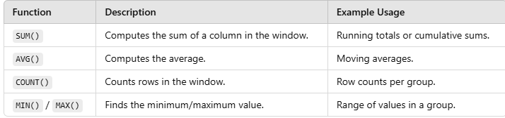
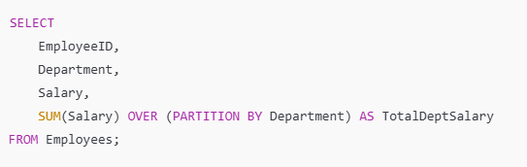
This calculates the total salary for each department without grouping the data.

b. Ranking Functions
Used to rank rows based on their order in the window.
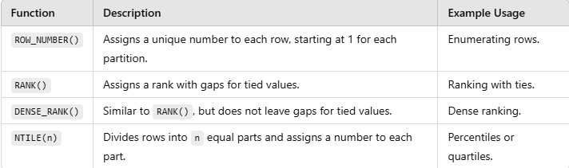
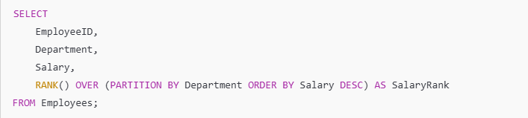
This ranks employees by salary within their department.
1. ROW_NUMBER ()
- Purpose: Assigns a unique sequential number to each row within a partition, based on the specified order.
- Syntax:
• Use Case: Identify the first row in each group or assign unique IDs to rows.
• Example:
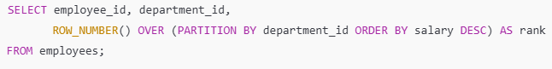
- Assigns a rank to each employee within their department based on salary.

2. RANK()
- Purpose: Assigns a rank to rows within a partition, with gaps in the ranks if there are ties.
- Syntax:
• Use Case: Ranking rows but allowing tied values to share the same rank.
• Example:
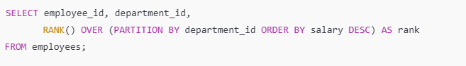
- If two employees in the same department have the same salary, they get the same rank, and the next rank is skipped.

3. DENSE_RANK()
- Purpose: Similar to RANK(), but without gaps in the ranking sequence.
- Syntax:
• Use Case: Rank rows without skipping ranks for ties.
• Example:
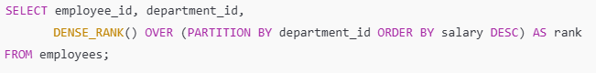
- Tied values receive the same rank, but subsequent ranks follow consecutively.

4. NTILE(n)
- Purpose: Divides rows into n roughly equal parts, and assigns a bucket number to each row.
- Syntax:
• Use Case: Splitting data into quantiles (e.g., quartiles, deciles).
• Example:
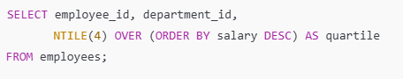
- Divides employees into 4 quartiles based on salary.

c. Value Window Functions
Retrieve values from other rows in the window.
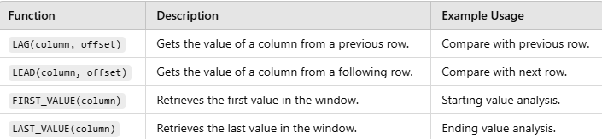
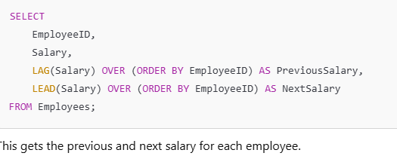
5. LAG()
- Purpose: Accesses the value of a column from the previous row in the same partition.
- Syntax:
- offset: Number of rows behind the current row to look.
- default: Value returned if the offset is outside the window.
• Use Case: Comparing values between consecutive rows.
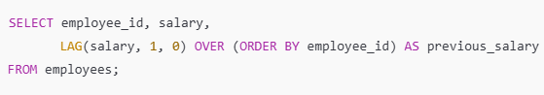
- Fetches the salary of the previous employee.

6. LEAD()
- Purpose: Accesses the value of a column from the next row in the same partition.
- Syntax:
- offset: Number of rows ahead of the current row to look.
- default: Value returned if the offset is outside the window.
• Use Case: Comparing values between rows in the forward direction.
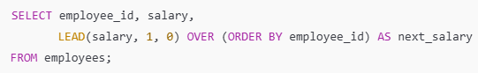
- Fetches the salary of the next employee.

7. FIRST_VALUE()
- Purpose: Returns the first value in the partition, based on the specified order.
- Syntax:
• Use Case: Find the earliest or smallest value in a group.
• Example:
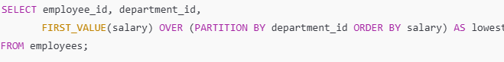
- Retrieves the lowest salary in each department.

8. LAST_VALUE()
- Purpose: Returns the last value in the partition, based on the specified order.
- Syntax:
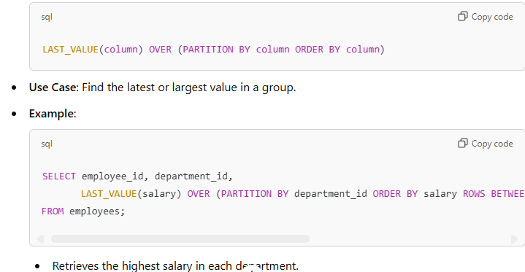

d. Statistical Window Functions
Perform statistical calculations within a window.
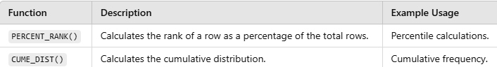
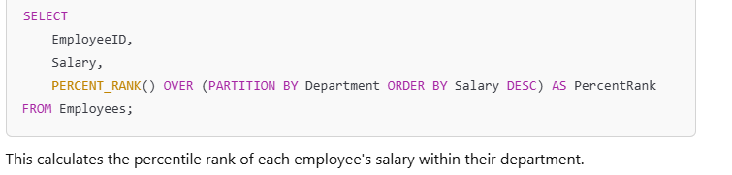
10. PERCENT_RANK()
- Purpose: Calculates the rank of a row as a percentage of the total number of rows in the partition.
- Syntax:
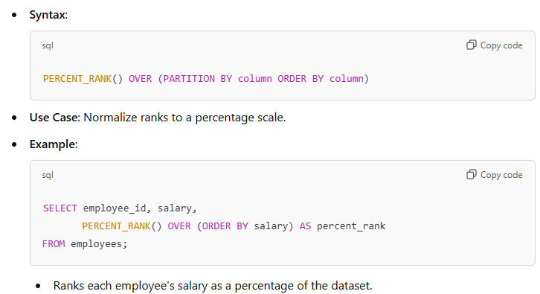

9. CUME_DIST()
- Purpose: Calculates the cumulative distribution of a value in its partition.
- Syntax:
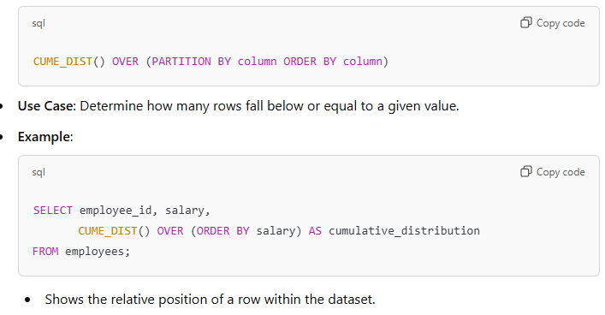

e. Window Frame Functions
Control the subset of rows used for a calculation.
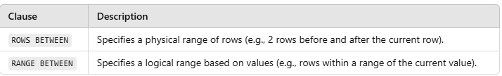
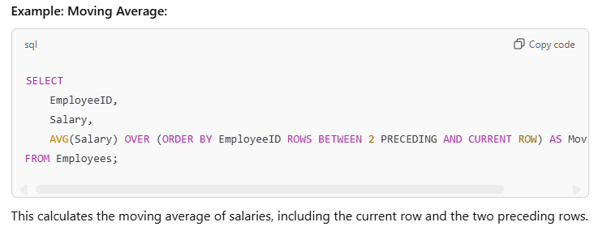
What COUNT(c.action = 'confirmed') Actually Does
- c.action = 'confirmed' is a condition that evaluates to either:
  - TRUE → Converted to 1
  - FALSE → Converted to 0
However, COUNT counts the number of rows, not the actual values of 1 or 0 from the condition. So COUNT(c.action = 'confirmed') will count all rows in which c.action is NOT NULL, regardless of whether they meet the condition (c.action = 'confirmed').
In short:
- COUNT does not filter based on the condition; it just counts rows.

Why SUM(c.action = 'confirmed') Works
- SUM adds up the values of the condition.
  - When c.action = 'confirmed', it evaluates to 1.
  - When c.action != 'confirmed', it evaluates to 0.
So, SUM(c.action = 'confirmed') only adds up the rows where c.action is 'confirmed'. It ignores the others because they evaluate to 0.

Example to Compare COUNT and SUM
c.action | c.action = 'confirmed' Result | SUM(c.action = 'confirmed') | COUNT(c.action = 'confirmed')
'confirmed' | 1 | Adds 1 | Counts 1
'timeout' | 0 | Adds 0 | Counts 1 (still a row)
'confirmed' | 1 | Adds 1 | Counts 1
- SUM(c.action = 'confirmed') = 1 + 0 + 1 = 2 (Correct count of 'confirmed').
- COUNT(c.action = 'confirmed') = 3 (Counts all rows, wrong for this task).

Why SUM is Better for This Task
We use SUM(c.action = 'confirmed') because:
- It adds up only the "true" results (1).
- It gives the correct count of rows where the action is 'confirmed'.
COUNT(c.action = 'confirmed') doesn’t work because it includes all rows, even when the condition is false.

COALESCE
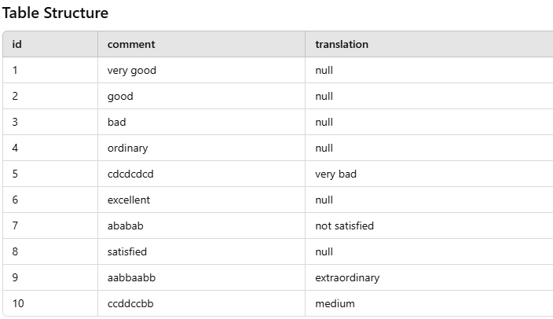
If you want NULL values in the translation column to be replaced by the corresponding comment values, while keeping the existing translation values unchanged where they are not NULL, you can use COALESCE with both the translation and comment columns.
Desired Behavior:
- If translation is NULL, replace it with the corresponding comment.
- If translation is not NULL, retain its existing value.

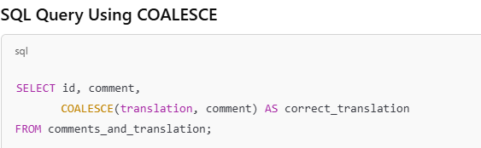
Explanation
- COALESCE(translation, comment):
  - This will check if translation is NULL.
  - If NULL, it will return the corresponding comment.
  - Otherwise, it retains the existing translation.
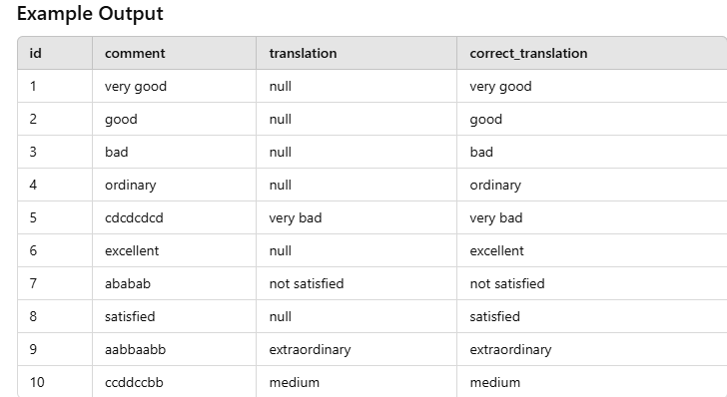

COALESCE Function: A Simple Explanation
The COALESCE function is a SQL function used to handle null values. It returns the first non-null value from a list of given values. If all the values are null, it returns null.
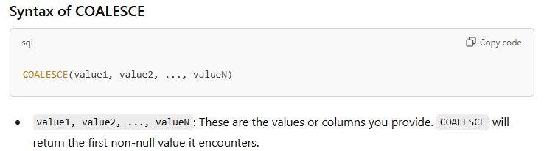
How It Works
- Evaluates each argument from left to right.
- Stops at the first non-null value and returns that value.
- If all values are null, it returns null.

Examples
1. Basic COALESCE Usage
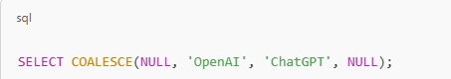
This would return 'OpenAI' because it's the first non-null value.

2. Using COALESCE with Columns
sql
Copy code
This will replace any NULL values in the email column with 'No email provided'.

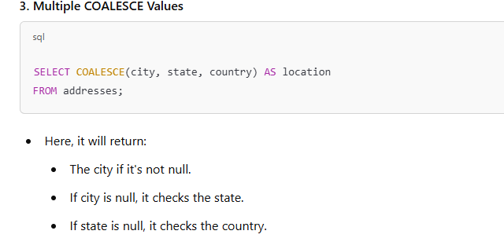
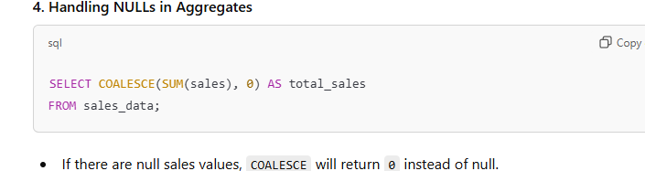
CTID
CTID (tuple identifier) is a system column in PostgreSQL that uniquely identifies the physical location of a row in a table. It is automatically generated for every row and is not visible by default unless explicitly selected in a query.
The CTID represents the exact physical storage location of a row, which is stored as a pair of numbers:
- Block number: Indicates the block within the table where the row resides.
- Offset: Identifies the row within that block.
A CTID value looks like this:
Key Features of CTID:
- System-Generated: CTID is automatically created and maintained by PostgreSQL.
- Physical Identifier: It indicates the physical storage location, not a logical identifier like a primary key.
- Temporary Nature: The CTID of a row can change over time if the row is updated or if the table undergoes operations like VACUUM FULL or CLUSTER.
- Useful for Low-Level Operations: It can be used to identify and work with specific rows, particularly for debugging or resolving database inconsistencies.

Where is CTID Useful?
- Row Identification: When no primary key or unique identifier is available, CTID can be used to temporarily locate and manipulate rows.
- Row Deletion or Updates: It helps in operations where duplicate rows exist and you need to target specific instances of those duplicates.
- Debugging: CTID is often used by database administrators for internal debugging or performance tuning.
- Detecting Duplicates: Helps in identifying specific rows when handling duplicates in a table.

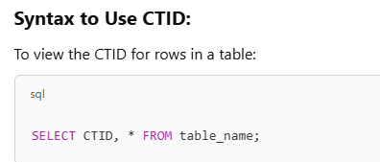
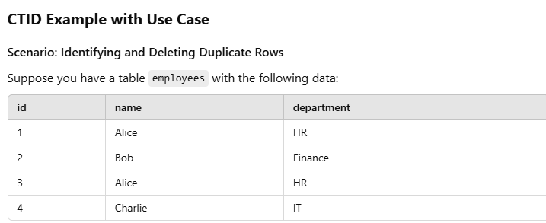
Here, rows 1 and 3 are duplicates. To delete only one of the duplicates, you can use the CTID column.
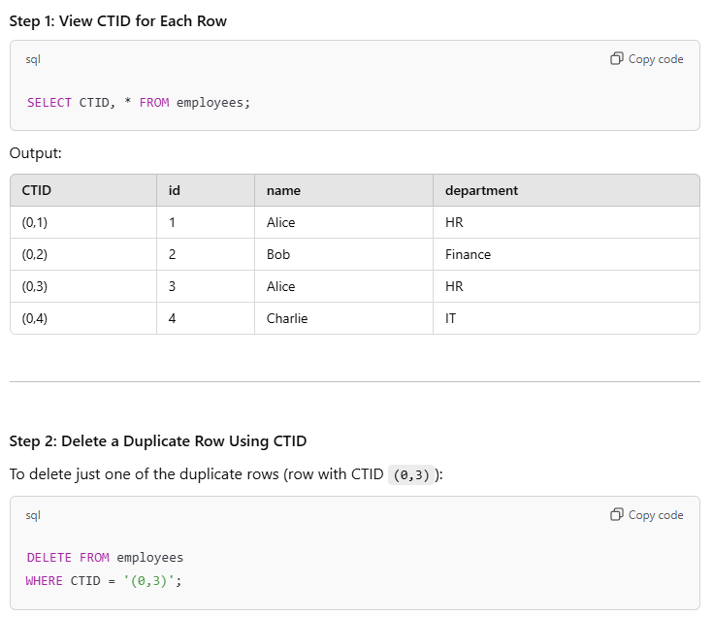
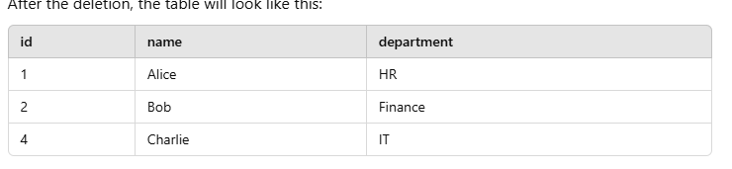
Limitations of CTID:
- Non-Persistent: CTID values change after certain operations like:
  - Row updates (a new CTID is assigned to the updated row).
  - Table reorganization (e.g., VACUUM FULL or CLUSTER).
- Not Suitable as a Primary Key: Since CTIDs are not consistent and can change over time, they should not be used as a substitute for primary keys.
- PostgreSQL Specific: CTID is available only in PostgreSQL and not in other relational database systems.

Advanced Use Case: Selecting the Latest Row
If you have multiple rows for the same data (e.g., same id) and want to pick the most recent version of the row based on CTID, you can use a query like this:
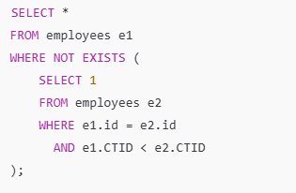
This query returns the row with the highest CTID (most recent version) for each id.

Summary of CTID:
- CTID is a PostgreSQL system column that provides a physical identifier for rows.
- It is useful for debugging, identifying duplicates, or performing specific row-level operations.
- CTID changes when rows are updated or tables are reorganized, so it should not be used as a primary key or persistent identifier.
- It’s a powerful tool when combined with standard SQL operations like DELETE, UPDATE, or subqueries.

Understanding ROWS UNBOUNDED PRECEDING and ROWS 1 PRECEDING
These phrases are part of window functions in SQL. Window functions operate on a set of rows defined by an over clause, and ROWS specifies a subset of those rows for the calculation.

What They Mean
- ROWS UNBOUNDED PRECEDING
  - Refers to all rows from the start of the partition up to the current row (inclusive).
  - Use Case: It is often used for cumulative calculations, like running totals.
Example:
SELECT SalesPersonID,
OrderID,
SUM(SalesAmount) OVER (PARTITION BY SalesPersonID ORDER BY OrderDate ROWS UNBOUNDED PRECEDING) AS RunningTotal
FROM Orders;

What happens: For each row, it calculates the sum of all SalesAmount values from the first row of the partition to the current row.
- ROWS 1 PRECEDING
- Refers to only the one row immediately before the current row.
- Use Case: This is useful for comparisons with the previous row, like calculating differences.
Example:

SELECT OrderID,
SalesAmount,
SalesAmount - LAG(SalesAmount) OVER (ORDER BY OrderDate ROWS 1 PRECEDING) AS ChangeFromPrevious
FROM Orders;

  - What happens: Subtracts the sales amount of the previous row from the current row.

Other Similar Statements
SQL supports additional types of window frame clauses to fine-tune how many rows to include for calculations:
ROWS Variants
- ROWS BETWEEN UNBOUNDED PRECEDING AND CURRENT ROW
  - Includes all rows from the start of the partition up to the current row.
  - Equivalent to ROWS UNBOUNDED PRECEDING.
  - Use Case: Cumulative sums or averages.
SUM(SalesAmount) OVER (PARTITION BY SalesPersonID ORDER BY OrderDate ROWS BETWEEN UNBOUNDED PRECEDING AND CURRENT ROW)

- ROWS BETWEEN CURRENT ROW AND UNBOUNDED FOLLOWING
- Includes the current row and all rows after it in the partition.
- Use Case: Calculating totals from the current row to the end of the partition.
SUM(SalesAmount) OVER (PARTITION BY SalesPersonID ORDER BY OrderDate ROWS BETWEEN CURRENT ROW AND UNBOUNDED FOLLOWING)

- ROWS BETWEEN 1 PRECEDING AND 1 FOLLOWING
- Includes one row before and one row after the current row.
- Use Case: Useful for calculating moving averages or smoothing data.
AVG(SalesAmount) OVER (PARTITION BY SalesPersonID ORDER BY OrderDate ROWS BETWEEN 1 PRECEDING AND 1 FOLLOWING)

RANGE Variants
RANGE is similar to ROWS, but it uses the value of the column rather than row positions.
- RANGE UNBOUNDED PRECEDING
  - Includes all rows where the value in the ORDER BY column is less than or equal to the current row's value.
  - Use Case: Useful for time-based calculations.

- RANGE BETWEEN INTERVAL '1' DAY PRECEDING AND CURRENT ROW
- Includes all rows within 1 day before the current row.
- Use Case: Time-based rolling calculations like a rolling 7-day average.

AVG(SalesAmount) OVER (ORDER BY OrderDate RANGE BETWEEN INTERVAL '7' DAY PRECEDING AND CURRENT ROW)

Understanding ROWS UNBOUNDED PRECEDING and ROWS 1 PRECEDING
These phrases are part of window functions in SQL. Window functions operate on a set of rows defined by an over clause, and ROWS specifies a subset of those rows for the calculation.

What They Mean
- ROWS UNBOUNDED PRECEDING
  - Refers to all rows from the start of the partition up to the current row (inclusive).
  - Use Case: It is often used for cumulative calculations, like running totals.
Example:
sql
Copy code
SELECT
SalesPersonID,
OrderID,
SUM(SalesAmount) OVER (PARTITION BY SalesPersonID ORDER BY OrderDate ROWS UNBOUNDED PRECEDING) AS RunningTotal
FROM Orders;
  - What happens: For each row, it calculates the sum of all SalesAmount values from the first row of the partition to the current row.
- ROWS 1 PRECEDING
  - Refers to only the one row immediately before the current row.
  - Use Case: This is useful for comparisons with the previous row, like calculating differences.
Example:
sql
Copy code
SELECT
OrderID,
SalesAmount,
SalesAmount - LAG(SalesAmount) OVER (ORDER BY OrderDate ROWS 1 PRECEDING) AS ChangeFromPrevious
FROM Orders;
  - What happens: Subtracts the sales amount of the previous row from the current row.

Other Similar Statements
SQL supports additional types of window frame clauses to fine-tune how many rows to include for calculations:
ROWS Variants
- ROWS BETWEEN UNBOUNDED PRECEDING AND CURRENT ROW
  - Includes all rows from the start of the partition up to the current row.
  - Equivalent to ROWS UNBOUNDED PRECEDING.
  - Use Case: Cumulative sums or averages.
sql
Copy code
SUM(SalesAmount) OVER (PARTITION BY SalesPersonID ORDER BY OrderDate ROWS BETWEEN UNBOUNDED PRECEDING AND CURRENT ROW)
- ROWS BETWEEN CURRENT ROW AND UNBOUNDED FOLLOWING
  - Includes the current row and all rows after it in the partition.
  - Use Case: Calculating totals from the current row to the end of the partition.
sql
Copy code
SUM(SalesAmount) OVER (PARTITION BY SalesPersonID ORDER BY OrderDate ROWS BETWEEN CURRENT ROW AND UNBOUNDED FOLLOWING)
- ROWS BETWEEN 1 PRECEDING AND 1 FOLLOWING
  - Includes one row before and one row after the current row.
  - Use Case: Useful for calculating moving averages or smoothing data.
sql
Copy code
AVG(SalesAmount) OVER (PARTITION BY SalesPersonID ORDER BY OrderDate ROWS BETWEEN 1 PRECEDING AND 1 FOLLOWING)

RANGE Variants
RANGE is similar to ROWS, but it uses the value of the column rather than row positions.
- RANGE UNBOUNDED PRECEDING
  - Includes all rows where the value in the ORDER BY column is less than or equal to the current row's value.
  - Use Case: Useful for time-based calculations.
sql
Copy code
SUM(SalesAmount) OVER (ORDER BY OrderDate RANGE UNBOUNDED PRECEDING)
- RANGE BETWEEN INTERVAL '1' DAY PRECEDING AND CURRENT ROW
  - Includes all rows within 1 day before the current row.
  - Use Case: Time-based rolling calculations like a rolling 7-day average.
sql
Copy code
AVG(SalesAmount) OVER (ORDER BY OrderDate RANGE BETWEEN INTERVAL '7' DAY PRECEDING AND CURRENT ROW)

Key Use Cases of Window Frame Clauses
- Cumulative Aggregations:
  - E.g., Running totals, cumulative averages.
  - Use ROWS UNBOUNDED PRECEDING.
- Comparisons with Previous/Next Rows:
  - E.g., Calculate the difference between consecutive rows.
  - Use ROWS 1 PRECEDING.
- Moving Averages or Smoothing:
  - E.g., 3-day rolling averages.
  - Use ROWS BETWEEN X PRECEDING AND Y FOLLOWING.
- Time-based Aggregations:
  - E.g., Rolling calculations over a time period.
  - Use RANGE.

Simplified Summary
- ROWS: Focuses on specific row positions (e.g., row before, current row).
- RANGE: Focuses on column values (e.g., time-based ranges).
- These clauses help solve complex queries easily, especially for trend analysis, cumulative calculations, or rolling averages.

Data Types in SQL: A Simple Explanation
Data types in SQL define what kind of data can be stored in a column of a table. They ensure that the data is stored and handled correctly. Here’s a detailed and simple explanation of the main categories of SQL data types:

1. Numeric Data Types
Used to store numbers.
a. Exact Numeric Types
For numbers where precision (exact value) is essential.
- INT (Integer): Whole numbers (e.g., 1, 42, -10).
- SMALLINT: Smaller range of whole numbers (e.g., 1 to 32,767).
- BIGINT: Large range of whole numbers (e.g., billions).
- DECIMAL or NUMERIC: Fixed-point numbers, great for money (e.g., 12.34, -99.99). You specify precision (total digits) and scale (digits after the decimal).
- TINYINT: Very small integers (e.g., 0 to 255).
b. Approximate Numeric Types
For numbers where precision is not critical (used for scientific calculations).
- FLOAT: For large decimal numbers with approximate precision (e.g., 3.14, 2.71828).
- REAL: Similar to FLOAT but with less precision.

2. String Data Types
Used to store text or alphanumeric data.
a. Fixed and Variable Length
- CHAR(size): Stores fixed-length text. Space is padded for shorter values (e.g., 'A' stored as 'A ' for CHAR(5)).
- VARCHAR(size): Stores variable-length text. Only uses space for the actual text (e.g., 'A' stored as 'A').
b. Large Text Data
- TEXT: Stores very large text like articles or descriptions (e.g., paragraphs).
- NCHAR and NVARCHAR: Like CHAR and VARCHAR but for Unicode characters, useful for storing multiple languages.
- NTEXT: Large Unicode text data (deprecated in modern SQL versions).

3. Date and Time Data Types
Used to store dates, times, and timestamps.
- DATE: Only the date (e.g., 2025-01-12).
- TIME: Only the time (e.g., 14:35:20).
- DATETIME: Both date and time (e.g., 2025-01-12 14:35:20).
- TIMESTAMP: Similar to DATETIME but includes timezone support.
- YEAR: Stores a year (e.g., 2025).

4. Binary Data Types
Used to store binary data like images, audio, or files.
- BINARY(size): Fixed-length binary data.
- VARBINARY(size): Variable-length binary data.
- BLOB (Binary Large Object): Stores large binary files (e.g., images, videos).

5. Boolean Data Type
Represents TRUE or FALSE values.
- Often implemented as BIT (e.g., 1 for TRUE, 0 for FALSE).

6. Spatial Data Types
Used to store geographic or spatial data.
- GEOMETRY: For points, lines, or shapes.
- GEOGRAPHY: For geographical data like latitude/longitude.

7. JSON Data Type
Used to store JSON (JavaScript Object Notation) formatted data.
- JSON: For storing structured data as text in JSON format.

8. Miscellaneous Data Types
- ENUM: A predefined list of values. Example: ENUM('Small', 'Medium', 'Large').
- SET: A collection of predefined values. Example: SET('a', 'b', 'c').
- XML: Stores XML formatted data.

How to Choose the Right Data Type?
- Numeric Data: Use INT, DECIMAL, or FLOAT depending on precision and size.
- Text Data: Use CHAR for fixed-length and VARCHAR for variable-length text. Use TEXT for long text.
- Dates/Times: Use DATE, TIME, or DATETIME based on your requirement.
- Binary Data: Use BLOB or VARBINARY for files.
- Special Cases: Use ENUM or JSON for predefined values or structured data.
Choosing the right data type ensures your database performs efficiently and stores data correctly.
- Examples
User-Defined Functions in SQL allow developers to create custom functions that accept parameters and return scalar values or tables. Below, each type is explained with detailed examples.

1. Scalar User-Defined Functions (UDFs) in SQL: Detailed User-Defined Function
Description:
- Returns a single scalar value (e.g., INT, VARCHAR).
- Supports basic calculations or transformations.
- Does not support complex data types like TEXT, IMAGE, or TIMESTAMP.
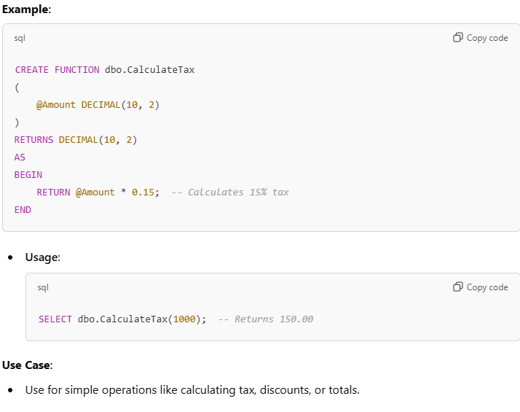
2. Inline Table-Valued User-Defined Function
Description:
- Returns a table data type.
- Acts as an alternative to views by passing parameters into a SELECT statement.
- Non-updateable table; cannot modify the underlying data.
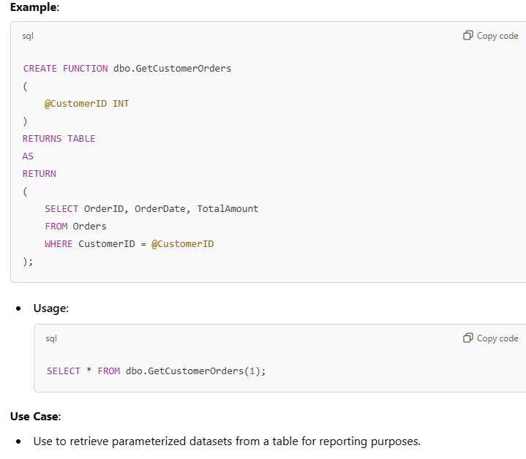
3. Multi-Statement Table-Valued User-Defined Function
Description:
- Returns a table by executing multiple SQL statements.
- Suitable for complex logic using multiple commands.
- Supports aggregations and joins, offering more flexibility than Inline UDFs.
Example:
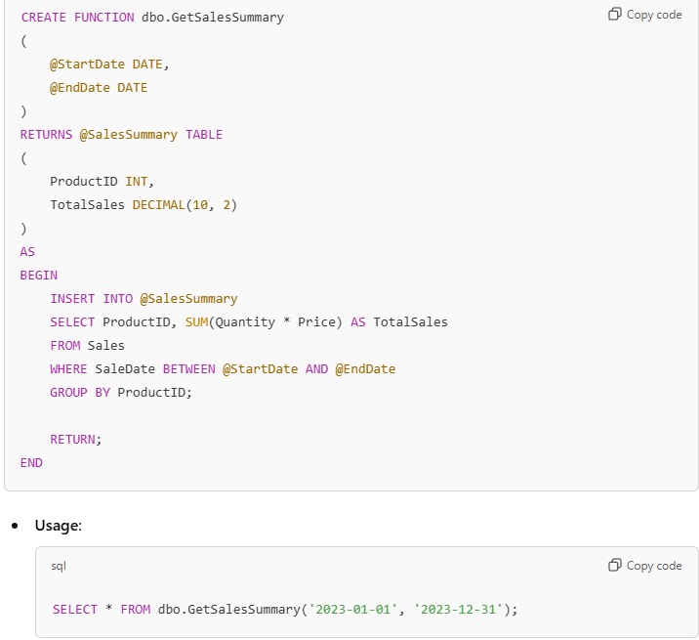
Use Case:
- Use for aggregating large datasets over time, especially in reporting or business intelligence scenarios.
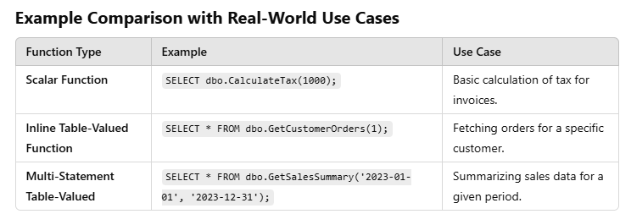

What is Pattern Matching in SQL?
SQL pattern matching provides for pattern search in data if you have no clue as to what that word should be. This kind of SQL query uses wildcards to match a string pattern, rather than writing the exact word. The LIKE operator is used in conjunction with SQL Wildcards to fetch the required information.
- Using the % wildcard to perform a simple search
The % wildcard matches zero or more characters of any type and can be used to define wildcards both before and after the pattern. Search a student in your database with first name beginning with the letter K:
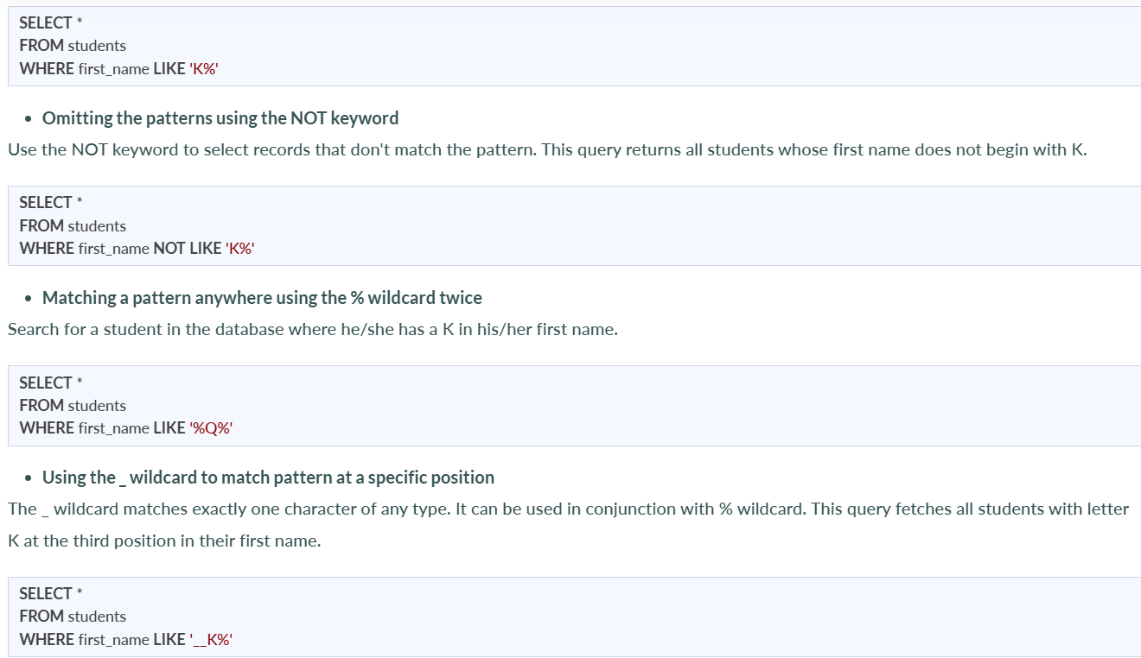
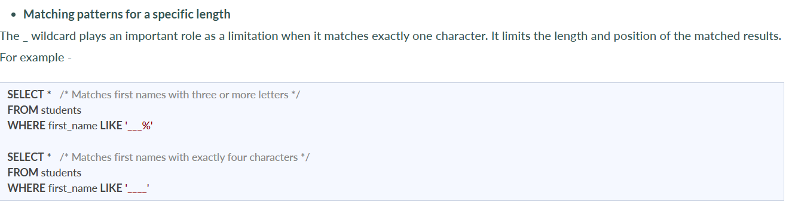

How to create empty tables with the same structure as another table?
Creating empty tables with the same structure can be done smartly by fetching the records of one table into a new table using the INTO operator while fixing a WHERE clause to be false for all records. Hence, SQL prepares the new table with a duplicate structure to accept the fetched records but since no records get fetched due to the WHERE clause in action, nothing is inserted into the new table.

What is Collation? What are the different types of Collation Sensitivity?
Collation refers to a set of rules that determine how data is sorted and compared. Rules defining the correct character sequence are used to sort the character data. It incorporates options for specifying case sensitivity, accent marks, kana character types, and character width. Below are the different types of collation sensitivity:
- Case sensitivity: A and a are treated differently.
- Accent sensitivity: a and á are treated differently.
- Kana sensitivity: Japanese kana characters Hiragana and Katakana are treated differently.
- Width sensitivity: Same character represented in single-byte (half-width) and double-byte (full-width) are treated differently.

What are the differences between OLTP and OLAP?
OLTP stands for Online Transaction Processing, is a class of software applications capable of supporting transaction-oriented programs. An important attribute of an OLTP system is its ability to maintain concurrency. OLTP systems often follow a decentralized architecture to avoid single points of failure. These systems are generally designed for a large audience of end-users who conduct short transactions. Queries involved in such databases are generally simple, need fast response times, and return relatively few records. A number of transactions per second acts as an effective measure for such systems.
OLAP stands for Online Analytical Processing, a class of software programs that are characterized by the relatively low frequency of online transactions. Queries are often too complex and involve a bunch of aggregations. For OLAP systems, the effectiveness measure relies highly on response time. Such systems are widely used for data mining or maintaining aggregated, historical data, usually in multi-dimensional schemas.

What is a UNIQUE constraint?
A UNIQUE constraint ensures that all values in a column are different. This provides uniqueness for the column(s) and helps identify each row uniquely. Unlike primary key, there can be multiple unique constraints defined per table. The code syntax for UNIQUE is quite similar to that of PRIMARY KEY and can be used interchangeably.

What is Data Integrity?
Data Integrity is the assurance of accuracy and consistency of data over its entire life-cycle and is a critical aspect of the design, implementation, and usage of any system which stores, processes, or retrieves data. It also defines integrity constraints to enforce business rules on the data when it is entered into an application or a database.
12. What is the difference between Clustered and Non-clustered index?
As explained above, the differences can be broken down into three small factors -
- Clustered index modifies the way records are stored in a database based on the indexed column. A non-clustered index creates a separate entity within the table which references the original table.
- Clustered index is used for easy and speedy retrieval of data from the database, whereas, fetching records from the non-clustered index is relatively slower.
- In SQL, a table can have a single clustered index whereas it can have multiple non-clustered indexes

What is an Index? Explain its different types.
A database index is a data structure that provides a quick lookup of data in a column or columns of a table. It enhances the speed of operations accessing data from a database table at the cost of additional writes and memory to maintain the index data structure.
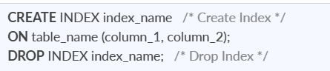
There are different types of indexes that can be created for different purposes:
- Unique and Non-Unique Index:
Unique indexes are indexes that help maintain data integrity by ensuring that no two rows of data in a table have identical key values. Once a unique index has been defined for a table, uniqueness is enforced whenever keys are added or changed within the index.

Non-unique indexes, on the other hand, are not used to enforce constraints on the tables with which they are associated. Instead, non-unique indexes are used solely to improve query performance by maintaining a sorted order of data values that are used frequently.
- Clustered and Non-Clustered Index:
Clustered indexes are indexes whose order of the rows in the database corresponds to the order of the rows in the index. This is why only one clustered index can exist in a given table, whereas, multiple non-clustered indexes can exist in the table.
The only difference between clustered and non-clustered indexes is that the database manager attempts to keep the data in the database in the same order as the corresponding keys appear in the clustered index.
Clustering indexes can improve the performance of most query operations because they provide a linear-access path to data stored in the database.

What are Constraints in SQL?
Constraints are used to specify the rules concerning data in the table. It can be applied for single or multiple fields in an SQL table during the creation of the table or after creating using the ALTER TABLE command. The constraints are:
- NOT NULL - Restricts NULL value from being inserted into a column.
- CHECK - Verifies that all values in a field satisfy a condition.
- DEFAULT - Automatically assigns a default value if no value has been specified for the field.
- UNIQUE - Ensures unique values to be inserted into the field.
- INDEX - Indexes a field providing faster retrieval of records.
- PRIMARY KEY - Uniquely identifies each record in a table.
- FOREIGN KEY - Ensures referential integrity for a record in another table.

What is the difference between SQL and MySQL?
SQL is a standard language for retrieving and manipulating structured databases. On the contrary, MySQL is a relational database management system, like SQL Server, Oracle or IBM DB2, that is used to manage SQL databases.

What is DBMS?
DBMS stands for Database Management System. DBMS is a system software responsible for the creation, retrieval, updation, and management of the database. It ensures that our data is consistent, organized, and is easily accessible by serving as an interface between the database and its end-users or application software.

What are Entities and Relationships?
Entity: An entity can be a real-world object, either tangible or intangible, that can be easily identifiable. For example, in a college database, students, professors, workers, departments, and projects can be referred to as entities. Each entity has some associated properties that provide it an identity.
Relationships: Relations or links between entities that have something to do with each other. For example - The employee's table in a company's database can be associated with the salary table in the same database.

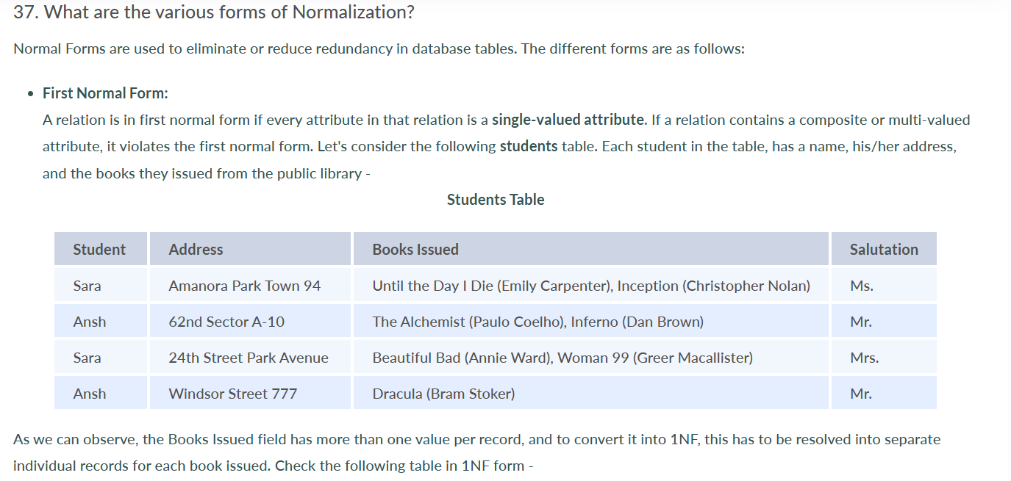
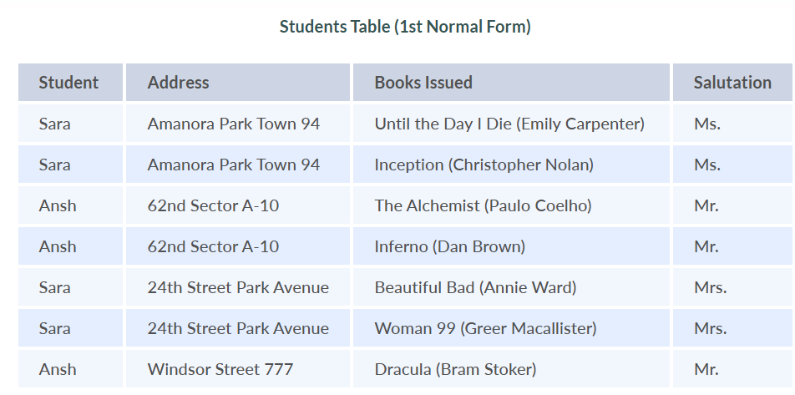

- Second Normal Form:
A relation is in second normal form if it satisfies the conditions for the first normal form and does not contain any partial dependency. A relation in 2NF has no partial dependency, i.e., it has no non-prime attribute that depends on any proper subset of any candidate key of the table. Often, specifying a single column Primary Key is the solution to the problem. Examples -
Example 1 - Consider the above example. As we can observe, the Students Table in the 1NF form has a candidate key in the form of [Student, Address] that can uniquely identify all records in the table. The field Books Issued (non-prime attribute) depends partially on the Student field. Hence, the table is not in 2NF. To convert it into the 2nd Normal Form, we will partition the tables into two while specifying a new Primary Key attribute to identify the individual records in the Students table. The Foreign Key constraint will be set on the other table to ensure referential integrity.
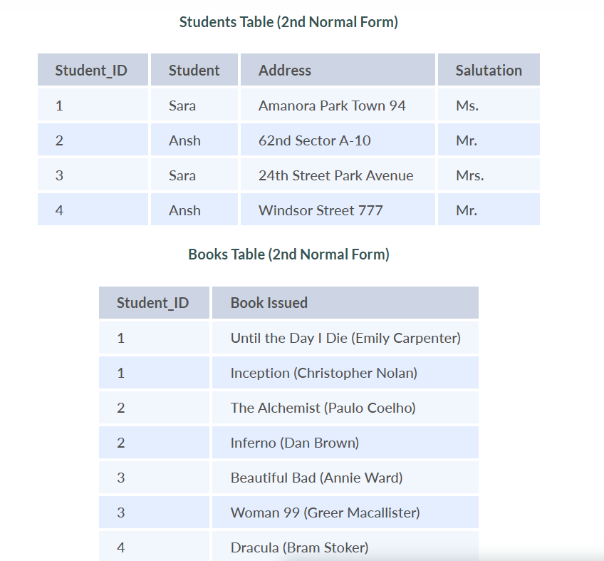

- Third Normal Form
A relation is said to be in the third normal form, if it satisfies the conditions for the second normal form and there is no transitive dependency between the non-prime attributes, i.e., all non-prime attributes are determined only by the candidate keys of the relation and not by any other non-prime attribute.
Example 1 - Consider the Students Table in the above example. As we can observe, the Students Table in the 2NF form has a single candidate key Student_ID (primary key) that can uniquely identify all records in the table. The field Salutation (non-prime attribute), however, depends on the Student Field rather than the candidate key. Hence, the table is not in 3NF. To convert it into the 3rd Normal Form, we will once again partition the tables into two while specifying a new Foreign Key constraint to identify the salutations for individual records in the Students table. The Primary Key constraint for the same will be set on the Salutations table to identify each record uniquely.
